HOW TO: Create a VPN Connection in Windows XP

1. Go to the Control Panel & open Network Connections
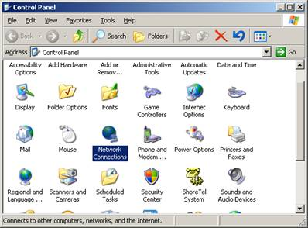

2. Start New Connection Wizard
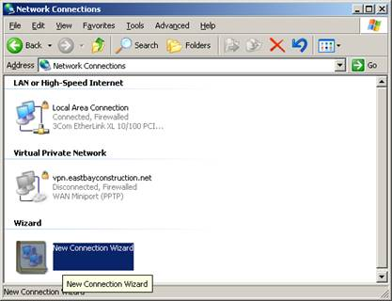

3. Click Next
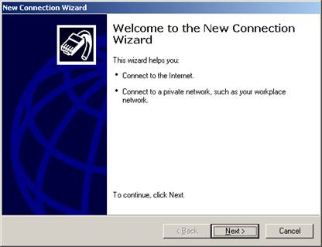

4. Select Connect to the network at my workplace, click Next
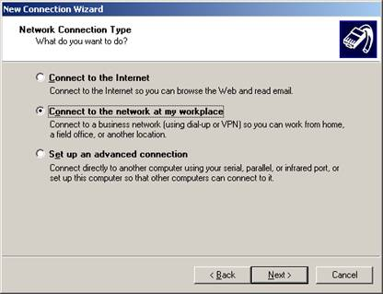
5. Select Virtual Private Network Connection, click Next
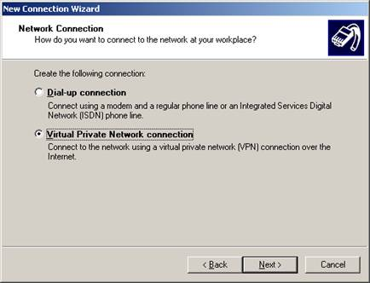

6. Enter Company name (i.e. ENCOSE VPN), then click Next
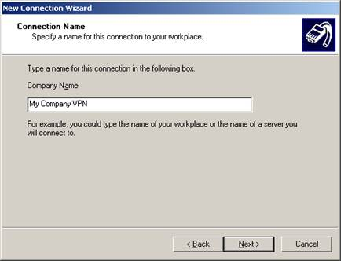
7. If prompted, Select Do not dial the internet connection, then click Next
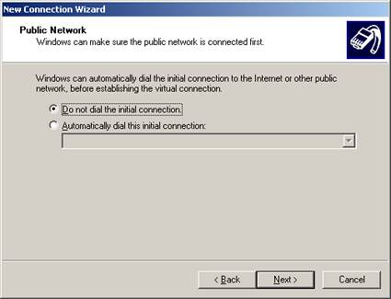

8. Enter VPN server info (i.e. vpn.encose.com), then click Next
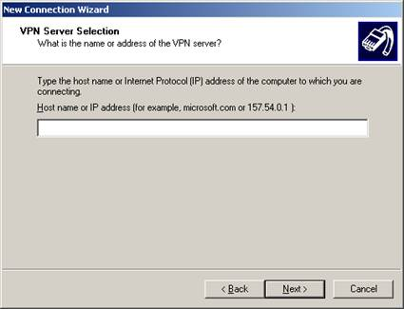

9. Select My use only, click Next
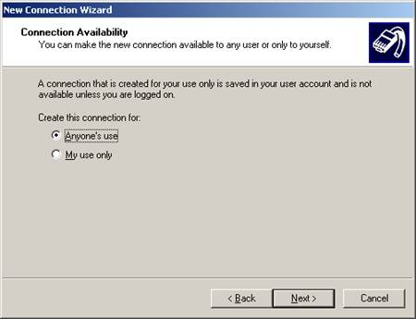

10. Check Add a shortcut to this connection to my desktop, click Finish
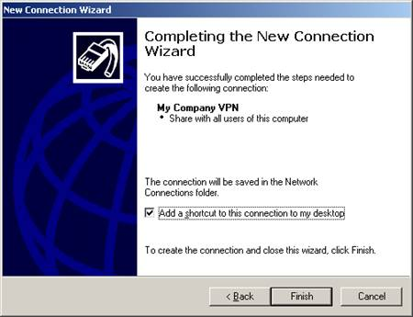

DONE
Your User name & Password is the same as your email user name & password

