Telrex Site Survey
All fields in this document must be completed and submitted to your Telrex Channel Account Manager prior to the Site Survey conference call. The conference call should have the customer, reseller, and the network engineer that will make necessary PBX and Port Mirroring changes. Please also attach a current network diagram in a PDF or MS Visio format for review by your Telrex Support Engineer. Without this information we will be unable to proceed with an installation.

Customer Information | Reseller Information
Company Name: | Company Name:
Contact Name: | Contact Name:
Job Title: | Job Title:
Industry: | Industry: Telecommunications
Telephone: Ext: | Telephone: Ext:
Email: | Email:
Address: | Address:
City: | City:
State: | State:
Country: | Country:
Zip Code: | Zip Code:
Installation Contact | Installation Contact
Name: | Name:
Office: Ext: | Office: Ext:
Mobile: | Mobile:
Alternate: Ext: | Alternate: Ext:
Email: | Email:
CallRex Product Information
Have you purchased our product or are you evaluating it?
How many CallRex licenses do you have?
How many Multimedia licenses do you have?
How many IntelRex licenses do you have?
Please enter your CallRex Serial Number: (If you do not have a serial number please go to http://www.telrex.com/download_callrex.htm to register and you will be emailed a Serial Number.
Have the installation files been downloaded onto the new CallRex server? (If you do not have the installation files please go to http://www.telrex.com/installer_callrex.htm and download the installation files)
Number of administrators that will access the CallRex Client interface:
Number of managers that will access the CallRex Client interface:
Number of agents/employees that access the CallRex Client interface:
Windows operating system (32 Bit - REQUIRED) for Client Interface:
What CRM package are you using?
What Call Center application are you using?
Please provide your reasons for call recording below: (ie Quality Assurance, Training, Legal Compliance)
PBX Information
PLEASE BE ADVISED THAT TELREX WILL NOT CONFIGURE ANY PBX; TELREX RELIES ON THE RESELLER TO MAKE ANY NECESSARY PBX CHANGES. IF THE PBX IS NOT CONFIGURED PROPERLY THEN CALLREX WILL NOT RECORD CALLS PROPERLY.
PBX manufacturer:
PBX model:
PBX software version:
Trunk type:
Total number of trunks:
Has audio encryption been disabled on the PBX? (REQUIRED)
If, 3Com have you purchased the 3Com Record and Monitor License? (REQUIRED)
Has VAD/Silence Suppression been disabled on the PBX? (REQUIRED)
Do you use Least Cost Routing with your PBX?
Is DHCP used?
*Note* If the DCHP server changes the IP address of the phone then CallRex must manually be updated with the new IP address. CallRex will not automatically update to the new IP address and works best with static IP addresses for the recorded phones.
Is User Mobility used? (e.g. ShoreTel Office Anywhere, Cisco Mobility Manager)
If Mitel, is Teleworker used?
TAPI/MiTAI
Typically call control information (ie. off hook, on hook, caller ID) is captured via packet sniffing, however, in some cases TAPI or MiTAI (Mitel-specific) may need to be used as an alternate source of call control information. For example, if a PBX does not have the ability to disable call control encryption, CallRex could use TAPI or MiTAI (Mitel PBX) as an alternate source of call control. Currently TAPI is supported for Avaya IP Office, Cisco Unified CallManager, and MiTAI is available for Mitel (3300 V6.1 ICP200 V3.1 only) PBXs. TAPI integration for ShoreTel is coming soon.
Will TAPI or MiTAI be used for this installation?
If yes, TAPI or MiTAI will need to be configured on the PBX and on the CallRex server. Below are the general guidelines for each PBX:
Avaya
- Enable TAPI on Avaya IP Office PBX.
- Install and configure Avaya TSP on the CallRex server.
Cisco
- Create a TAPI user group within CallManager. Add all base extensions that are being recorded to this user group.
- Install and configure Cisco TSP on the CallRex server.
Mitel
- Enable MiTAI support on the 3300 V6.1 or ICP 200 V3.1
- Install and configure MiTAI on the CallRex server.
- *NOTE* MiTAI only support 10 Key Lines and 5 Multi-Call Groups
Dial Plan
Does each phone have a unique base extension? (REQUIRED)
Do phones have more than one extension?
If yes, how many extensions?
Do you want to record extension mobility users? CallRex must be setup with both with base extension users and extension mobility users.
Do you use shared extensions?
Do you use hunt groups?
Do you Key Line appearances?
If yes, what is the highest number of Key Lines extensions on one phone that will be recorded?
Do you use Multi-Call Groups
If yes, what is the highest number of Multi-Call group extension on one phone that will be recorded?
Is there an ACD use at the site?
If yes, what in the make and model?
Is an auto-dialer/predictive-dialer in use at the site?
If yes, do you want to record out bound calls?
What is the make and model?
In the below box please provide a brief description of inbound and outbound call flow process for the calls that will be recorded.
Hard Phones
Telephone Manufacturer(s):
Telephone Model Numbers (s):
Telephone Firmware Version (s):
Soft Phones
Do you intend to record Soft Phones?
If yes, which PBX Soft Phone will you record?
Application Version:
Are the audio or call control ports editable?
*NOTE* CallRex will only record with the default ports
Codecs
Codecs Used (select all that apply): |  | --
How many recorded phones use the G.729 codec?
*NOTE* G729 is not supported for live monitoring
Data Switch Information
PLEASE BE ADVISED THAT TELREX SUPPORT WILL NOT CONFIGURE ANY DATA SWITCH NOR TROUBLESHOOT YOUR NETWORK; TELREX RELIES ON THE RESELLER TO MAKE ALL NECESSARY NETWORK CHANGES. IF THE PORT MIRRORING IS NOT CONFIGURED PROPERLY THEN CALLREX WILL NOT RECORD CALLS PROPERLY.
Data switch manufacturer
Data switch model
What speeds does your data switch support?
Does your data switch support many to one port mirroring? (REQUIRED)
Does your data switch support mirroring ingress (RX) and egress (TX)? (REQUIRED)
Does your data switch support IP connectivity on the destination port? (REQUIRED)
Data connection type:
Port Mirroring Information
There are two basic types of port mirroring setups (see figure 1 for more details):
- If you would like to record only inbound and outbound calls and not internal calls you should mirror all PBX ports and all trunk ports.
- If you would like to record inbound, outbound, and internal calls you should mirror all phone ports via a VLAN. (NOT RECOMMENDED)
Please note the following:
- You should NOT setup port mirroring on both PBX/trunk ports and phones ports.
- There is no setting within CallRex Client to record internal vs external calls. CallRex will record based on the packets it gets via port mirroring.
Do you want to record inbound and outbound calls only?
Do you want to record inbound, outbound and internal extension calls?
CallRex Server Specifications
Does the server have internet access? (REQUIRED)
Will this be a dedicated server? (REQUIRED)
Number of CPUs:
CPU speed:
CPU type:
Total RAM:
Are there two Network Interface Cards installed? (REQUIRED)
Do you have a sound card installed? (REQUIRED)
Hard drive size:
Type of hard drive:
Windows operating system (32 Bit - REQUIRED):
OS Service Pack:
Server Sizing Information
What is the total number of simultaneous calls being recorded?
What is the average length of each call?
What is the average number of calls taken each month?
Load Balancing Agent Specifications
All CallRex servers recording over 100 simultaneous calls on one site are required to have a Load Balancing Agent.
Number of CPUs:
CPU speed:
CPU type:
Total RAM:
Are there two Network Interface Cards installed? (REQUIRED)
Do you have a sound card installed?
Hard drive size:
Type of hard drive:
Windows operating system:
OS Service Pack:
Multi-Site Deployments
CallRex uses Data Collectors (DCs) for remote site support. DCs may operate in either Live or Polling mode. Live mode sends all calls back to the main CallRex server for processing. Polling mode processes calls on the DC and sends the recordings back to the main server on a pre-defined schedule. Polling mode uses less network bandwidth, but does not support monitoring. A DC in polling mode must be sized like any other CallRex server.
Do you need to record multiple sites?
How many Data Collectors are needed?
Will the Data Collector be in Live or Polling mode?
PBX Information
PBX manufacturer:
PBX model:
PBX software version:
Has audio encryption been disabled on the PBX?
Has VAD or Silence Suppression been disabled on the PBX?
Trunk type:
Total number of trunks:
Data Switch Information
Data switch manufacturer
Data Switch model
What speeds does your data switch support?
Does your data switch support many to one port mirroring?
Does your data switch support mirroring ingress (RX) and egress (TX)?
Does your data switch support IP connectivity on the destination port?
Data connection type:
Data Collector Server Specifications
Does the server have internet access?
Will this be a dedicated server?
Number of CPUs:
CPU speed:
CPU type:
Total RAM:
Are there two Network Interface Cards installed?
Do you have a sound card installed?
Hard drive size:
Type of hard drive:
Windows operating system:
OS Service Pack:
Server Sizing Information
What is the total number of simultaneous calls being recorded?
What is the average length of each call?
What is the average number of calls taken each month?

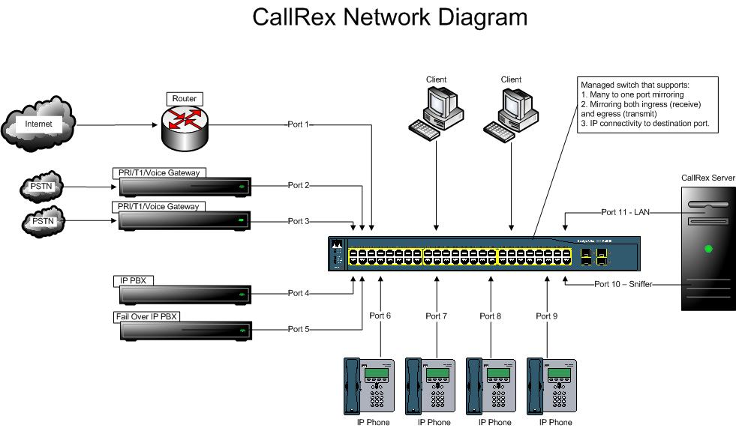
Figure 1

Overview

CallRex records and monitors telephone calls by sniffing packets traversing across the data network. Packet sniffing is achieved by enabling port mirroring on the data switch. Port mirroring is supported by most data switches and when enabled will send a copy of every packet destined for one port to another port. The managed switch must support many to one port mirroring, mirroring both ingress (receive) and egress (transmit), and IP connectivity to the destination port.

Port Mirroring
There are several different types of port mirroring setups:

- If you would like to record only inbound and outbound calls and not internal calls you should mirror all PBX ports and all trunk ports. In the above diagram your source ports will be ports two through five (PBX/Trunk Ports) and your destination port will be port 10 (CallRex). This applies only to PBXs on site.
- If you have a hosted or an off-site PBX (e.g. Covad, Sylantro, Broadsoft, Tekelec) then you should setup port one (router) as the source port and port ten (CallRex) as the destination port. This will allow you to record all inbound and outbound calls but not internal calls. This applies to PBXs offsite.
- If you would like to record inbound, outbound, and internal calls you should mirror all phone ports via a VLAN. In the above diagram you will need to assign ports six through nine and place them in a VLAN and setup the VLAN as the source port and port ten (CallRex) as the destination. This applies to any PBX on or off site however this solution is NOT RECOMMENDED due to the high level of complexity in creating a port mirroring session for all the phones on the network.
- If this is a multi-site deployment then you can use a combination of the above port mirroring setups. Below are a few examples:
  - If you have two sites, both of which have PBXs on site, then you can use option one on both sites.
  - If you have a PBX/trunk on the main site and no PBX/trunks on the remote site then you can use option one on the main site and option two on the remote site.
  - If you have a PBX/trunk on the main site and only a trunk on the remote site then you can use option one for the main site and monitor port one (router) and port two and three (trunks) as source ports and port ten (CallRex) as destination port for the remote site.

There are a variety of a port mirroring setups that can be utilized however please consult a Telrex Support Engineer prior to setting up port mirroring.

*NOTE*
- You should NEVER setup port mirroring on both PBX/trunk ports and phones ports.
- There is no setting within the CallRex Client to record internal vs external calls. CallRex will record based on the packets it gets via port mirroring.
- Some PBXs (Avaya & ShoreTel) allows internal phone extension traffic to go through the PBX instead of the data switch. If you have configured your PBX to do this, then you can record internal calls via port mirroring on the PBX/Trunk ports.

Telrex Internal Use Only

Please initial & forward to the next person on the list.
Reseller:
Telrex Installer/Engineer:
Telrex Channel Account Manager:

Estimated Installation Time:

Once form is completed and approved, Telrex Support may schedule the installation.

