Survival Guide to the Call Manager application suite

Version 8.2
Mike Tovino
Last updated 10/2/2003

Introduction

This document provides some high-level information about the Call Manager application suite that may help you test and support the product.

Here is a listing of the applications that make up the suite:

Personal Call Manager

The Personal Call Manager, nicknamed “Ollie” (Ask a snowboarder, skateboarder, or wake boarder what the name means), is the centerpiece of the suite. Users can make calls, take calls, and manage calls from here. Figures 1 – 3 show the three views of PCM. (When I refer to PCM or “Ollie” throughout this document I am referring to all the flavors: Advanced, Operator, etc as well).

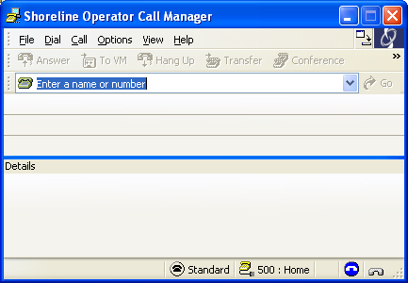

Figure 1. Personal Call Manager, Detailed View.

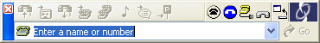

Figure 2. Personal Call Manager, Compact View

Figure 3. Personal Call Manager, Docked View

Extension Monitor

The Extension Monitor is available to all users who have the Operator client type. It allows the user to spy on other extensions. The user can choose which extensions to spy on by choosing Options/Select Extensions. The Extension Monitor has different views as well. Figures 4 – 6 show those views:

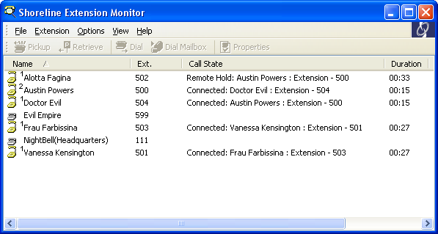

Figure 4. Extension Monitor, standard view

Figure 5. Extension Monitor, docked top/bottom

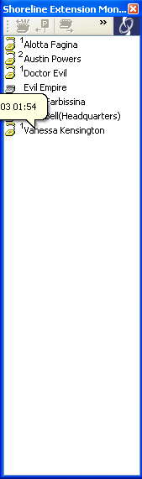

Figure 6. Extension Monitor, docked left/right

Agent Monitor

The Agent Monitor is available to anyone who has the WG Supervisor or Operator client type who is a member of a workgroup. It is almost exactly the same as the extension monitor except that it shows who is in the same workgroup that you are in, plus it shows whether the agents status in the workgroup.

The Agent Monitor also has the same views as the Extension Monitor; only the standard view is shown here in Figure 7.

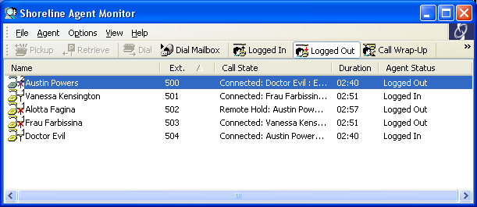

Figure 7. Agent Monitor

Queue Monitor

The Queue Monitor is available to anyone with a Workgroup Supervisor, Workgroup Agent, or Operator client type who is a member of a workgroup. It allows you to view queue statistics on the workgroup to which you belong. It has a detailed and a compact view, shown in Figures 8 and 9.

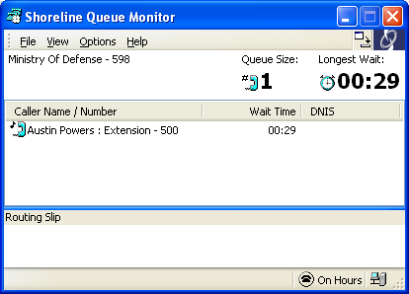

Figure 8. Queue Monitor Detailed View

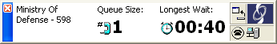

Figure 9. Queue Monitor, Compact View.

Directory Viewer

The Directory Viewer allows one to view and edit (where applicable) Shoreline Directory entries. System entries are read-only. Personal entries can be created, modified, and deleted.

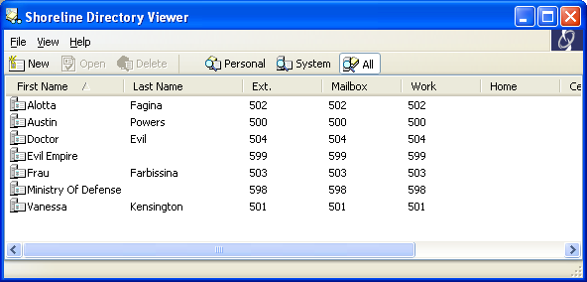

Figure 10. Directory Viewer

History Viewer

The History Viewer allows one to view locally stored information about completed calls. The History file is generated by Personal Call Manager; thus, any calls that occur while Personal Call manager is not running will not be found in the History Viewer.

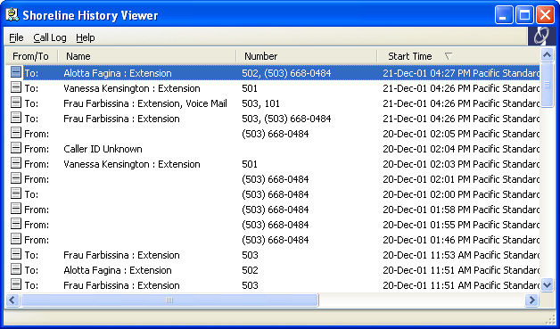

Figure 11. History Viewer

Configure Shoreline System (Control Panel applet)

The Shoreline control panel applet allows you to configure your Shoreline account and applications. It can be accessed from the Call manager, Voice Mail viewer or from the Windows control panel.

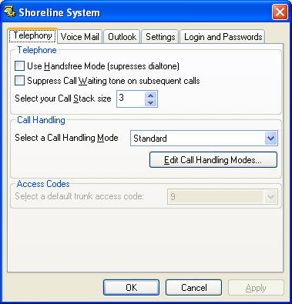

Figure 12. The Control Panel applet

Voice Mail Viewer

The Shoreline Voice Mail viewer allows the user to listen to, manage, and compose voice mails, and manage their distribution lists.
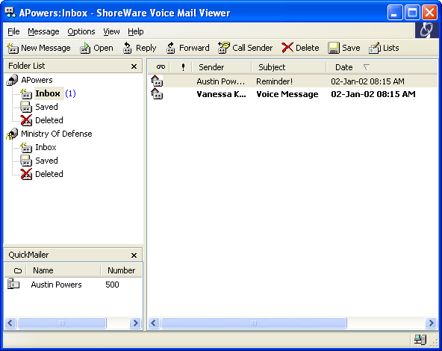

Figure 13. Shoreline Voice Mail viewer.

Operation Theory

Figure 14 shows the basic client component architecture as it relates to the Call Manager applications. The following explanations may make it easier to understand Figure 14.

All Call Manager applications are hosted inside a single process called STCHost.exe. The single host process has two huge advantages and one small disadvantage over having everything separate.

The first advantage is that most of the applications work with essentially the same data set. They share the one data set and this takes less memory. The second advantage is that once you’ve established a connection to CSIS and TAPI by launching Personal Call Manager, starting the other applications is pretty much instantaneous.

The disadvantage is that if one application crashes, they all crash. This is a small price to pay, especially considering crashes should be rare – all message loops and threads are protected at a high level against crashes.
The Call Manager applications do the bulk of their communications with two entities on the server: CSIS and TAPI.

All Telephony related data and functions go through TAPI; all Voice Mail and Database related data and functions go through CSIS. The Call Manager applications will use whichever services are available and attempt to degrade gracefully when one of the services is not available.

Personal Call Manager, Extension Monitor, Agent Monitor, and Queue Monitor are the only applications that actually communicate with TAPI. The others use Personal Call Manager as a proxy in order to dial calls. By this, I mean that they invoke Personal Call Manager to place the call on their behalf. This means that other applications will never show any kind of feedback when a call placement fails. However, the feedback *will* be shown in Personal Call Manager.

The four applications that talk to TAPI share a common library called STCLogic.dll. STCLogic.dll managers a single connection with TAPI on behalf of any of the four applications that are running. It has internal logic that decides which extensions need be monitored at any point in time. This logic is capable of handing anything except and upgrade without shutting down – a user’s extension can change and all the clients will keep humming along, simple switching over to monitor the new extension.

With the exception of the Voice Mail Viewer, all the applications that talk to CSIS do so through a common interface that is located in STCfgHlp.dll. This DLL manages an event queue that receives notifications from CSIS as well as outbound calls to CSIS. The Voice Mail Viewer also has a separate interface with CSIS that manages messages.

The Call Manager logs call activity to a text file, and the history viewer reads from it. The text file is always called history.txt. On Windows NT/2K/XP, the file will be in the user’s Application Data directory, under ShoreWare Client/<username>. On Windows 98/ME, the log file goes under a subdirectory of the ShoreWare Client install directory.

A separate process called STMapiRd.exe is invoked to stuff Outlook contact data into the Call Manager’s “white pages”. This is done in order to keep resource usage down – the import process can consume quite a bit of memory which is not reclaimed until the hosting process terminates. This resource issue is technically a bug in Microsoft Outlook and MAPI.

Figure 14. Call Manager architecture

Executable module listing

The following is a list of top-level executable modules that are used by PCM. This should help you decode any crash messages that you hopefully won’t encounter.

Module Function Engineer
StartCli.exe Call Manager launcher. This Mike Tovino
Is what the PCM shortcut launches.

STCHost.exe Call Mgr host executable Mike Tovino

STCfgApp.cpl Control Panel launcher Mike Tovino

SendLogs.exe Sends client logs to support Mike Tovino

STMapiRd.exe Executable that reads MAPI contacts Mike Tovino
And stuffs them into PCM

SendLogs.exe Sends client logs to support Mike Tovino

CSISCMgr.exe Client-side CSIS component Ken Robesky

Agent.exe Sync VM changes between Outlook Ken Robesky
And Voice Mail server

TAPISRV.exe/SvcHost.exe TAPI Microsoft/Kishore

RPCTSP.TSP TAPI Service Provider Kishore Nadimpalli

Starting the Client Applications

All of the Call Manager applications are hosted from a single process called STCHost.exe which is an out-of-process COM server.

In order to start a client application, one uses the launcher executable called StartCli.exe. This is what any desktop or start menu shortcuts will point to.

Simply invoking StartCli.exe will start Personal Call Manager and any other applications that were running at the time that Personal Call Manager was last exited.

There are a number of command line arguments that can be applied to StartCli in order runs single applications or run test modes.

- –cm runs only Personal Call Manager. Additional flags may be specified after –cm, in any combination:
  - -n [ext number] runs PCM in TAPI only mode, against the specified extension. No MAPI or CSIS connection is made. (MAPI connections can be added via –o or –p)
  - –d [debug flags] runs PCM with the specified debug flags set, overriding the registry. No [debug flags] argument turns them all on. See Appendix B for more information on debug flags.
  - –g [level] runs PCM in GUI-only mode; no TAPI, MAPI, or CSIS connections are made. This is useful for debugging painting issues. Level 1 is the full-featured GUI; level 2 and higher does not allow docking.
  - –j turns on Just-in-time monitoring regardless of client type; in other words, it turns a Personal client into an Advanced client. –j x adds Extended JIT info (call stack details and cal handling details).
  - –x allows access to the Extension Monitor regardless of client type. Specifying –j x –x turns any client type into an Operator client type. Operator client type includes all WG features as well, if the user is a member of a WG.
  - –l [# seconds] automatically exist the client after the specified number of seconds. The default value is 30 seconds. This is useful in conjunction with loginout_cc.bat for running automated login/out tests.
  - –o turns on Outlook contact import regardless of your settings. This can be used in conjunction with –n.
  - –p turns on Outlook contact import and popping regardless of your settings. This can be used in conjunction with –n.
- -vm runs the Voice Mail Viewer. (There will be a shortcut to this on the Start Menu.)
- -cpl runs the Control Panel Applet
- -amon runs the Agent Monitor. This won’t be particularly useful unless the user is a member of a WG.
- -qmon runs the Queue Monitor. This won’t be particularly useful unless the user is a member of a WG. The following options can be added:
  - –a shows all calls against the Queue extension, not just those marked as “queued” by the WG server.
  - –q [queue ext] runs against a specific queue extension. Must be used with –n.
  - –n [user ext] runs as a specific user. Must be used with –q
  - –d [debug flags] sets debug flags. If –test is not used, this will affect debug flags for all apps running inside STCHost.exe. See appendix B.
- -xmon runs the Extension Monitor.
- -hist runs the History Viewer. You can add the following options:
  - –n [ext number] run as extension number. Useful for reading history files previously created by PCM in TAPI-only mode.
- -stop shuts down all Call Manager applications. This can be useful if you are changing users and don’t want to logoff. It does not, however, shut down Outlook or other MAPI applications
- -test runs the specified application inside StartCli.exe rather than invoking STCHost.exe. This is very useful for running applications through the debugger and for isolating single applications inside their own processes. –test must be the first command line argument.
- -ShoreDevHelp shows a help screen with the first tier of options.

Examples:

1) To run PCM in TAPI only mode against extension 500:

StartCli –cm –n 500

2) Same, but run inside StartCli.exe instead of STCHost.exe:

StartCli –test –cm –n 500

3) To make yourself an Operator:

StartCli –cm –j x –x

(Please do not make yourself an operator on the Live System without obtaining permission from I.T., and then only for troubleshooting purposes. If you want to be an operator for any other reason, you should ask to be made one in Director).

Note: If you want to run multiple Call Managers, the second and subsequent Call Managers MUST be run in TAPI only mode and they MUST be run using –test.

The Setup Wizard

The Setup Wizard is part of the client and picks up where the installer leaves off in terms of configuring the Call Manager applications. Typically, the only time a user should see the setup wizard is the first time they run Personal Call Manager on a given machine. However, they may see it again if they cancel it the first time, refuse to record a name prompt, or if they later install Microsoft Outlook.

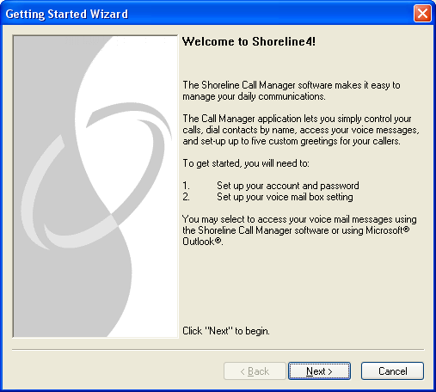

Figure 15. The Setup Wizard

The Setup Wizard runs if ANY of the following are true:

- Any of the following string values are not present or blank in the registry:
  - HKEY_CURRENT_USER\Software\Shoreline Teleworks\ShoreWare Client\UserName
  - HKEY_CURRENT_USER\Software\Shoreline Teleworks\ShoreWare Client\Server
  - HKEY_CURRENT_USER\Software\Shoreline Teleworks\ShoreWare Client\Password
- The following DWORD values are not present in the registry:
  - HKEY_CURRENT_USER\Software\Shoreline Teleworks\ShoreWare Client\LoadOutlookPhoneNumbers
- The following values are set to TRUE in the user's row in the USER table in the Database:
  - MustChangeGUIPassword
  - MustChangeTUIPassword
  - MustRecordName
- Outlook is installed AND VM Outlook Integration is not installed AND the following DWORD value is either not present in the registry or set to z nonzero value:
  - HKEY_CURRENT_USER\Software\Shoreline Teleworks\ShoreWare Client\OfferToInstallOutlookIntegration

Making any one or more of these conditions true and then starting the client will result in the wizard being run. (Note: You must exit the client from the system tray and more sure STCHost.exe terminates before deleting or setting the registry values, if you delete or set the registry values by hand first it is possible that they will be overwritten when you exit the client apps)

In order to simulate a fresh install:

- Exit all client apps - wait for STCHost.exe, CSISMgr.exe, STCLogin.exe, STMapiRd.exe to terminate
- If running an NT product (NT, 2K, XP) type "net stop tapisrv" from command prompt and wait for the telephony service to stop
- Delete the tree HKEY_CURRENT_USER\Software\Shoreline Teleworks\ShoreWare Client from the registry
- Edit the database and set the three values in the USER table mentioned above to TRUE. (TRUE is -1 in Access)
- Start the client.

Note: All things stored in the registry are gone, so expect it to have forgotten all kinds of thing like screen locations, which extensions are monitored in extension monitor, etc.

Troubleshooting

If any of the Call Manager applications appear to be malfunctioning, you should perform these quick diagnostic steps to determine whether the failing is in the application or in one of the components it depends upon. Once you have done this, you can either remedy the situation or call upon the proper engineer depending on the situation.

Login / startup problems

The following information will be helpful in debugging login problems on any of the Call Manager applications. For the purpose of this discussion, “login problems” mean only those having to do with CSIS. TAPI problems will be dealt with later.

How to identify a login problem

Any of the following are signs of login problems:

- Personal Call Manager does not show its main window when you double-click the icon.
- Personal Call Manager comes up, but there is no Call Handling Mode or Handsfree Mode icon on the status bar / app tray.
- Agent Monitor comes up but shows no agents
- Extension Monitor comes up, but shows only extension numbers, no names
- Voice Mail Viewer does not come up
- Control Panel comes up, but most fields are grayed out
- Directory Viewer comes up, but shows no data.

Far and away the most common symptom will be the second one: Personal Call Manager comes up, but there are no Call Handling Mode / Handsfree Mode status indicators. Here’s why:

The very first time Personal Call Manager successfully connects to CSIS, it stores a minimal amount of configuration in the user’s registry settings. This stored data is kept up to date the whole time the PCM is running. This data includes the user’s current extension number, the values of the system extensions (AA, BAA, VM, VM Login), the values of the paging and night bell extensions for the user’s current site, and user’s current Home Country, Home Area Code, and Default Access Code.

This data is sufficient to allow PCM to do it’s more important jobs: Display call information and allow the user to place and manage calls. If CSIS is not available to log the user in next time they start PCM, or the login fails, PCM simply uses the cached data until CSIS does com online and the login attempt succeeds. In fact, PCM comes up *before* login even starts – so it is using cached information for the first few seconds *every* time you start it!

This means that the only time a login problem could cause Personal Call Manager to not come up is if the user has not run it since they installed or upgraded to the Goleta Beach or Iona Beach release.

The other Call Manager apps are more damaged by login failures. In general, they all come up before login is completed, but aren’t particularly useful until a successful login is achieved.

How login works

Login begins by instantiating the CSIS COM object and initializing it. Any number of installation issues – missing files, failure to register the COM objects, a few out-of-date CSIS files, could cause login to fail every time.

All CSIS interactions run on a single background thread, including login. This prevents CSIS operations from locking up the UI.

Once the object is initialized, the client thread that interacts CSIS goes runs an event loop. This event loop processes events from CSIS itself (notifications of database changes and service state changes, and login completions), and events from the applications. The application events would generally come from GUI actions taken by the user – for example, changing a call handling mode, adding a new Personal Directory entry, recording a greeting for your Extended Absence call handling mode. Expect it to take CSIS between 2 and 6 seconds to send back the events that tell the client that it is successfully logged on. Unless, of course, you are starting a second client application – response will in that case be immediate.

How to tell that a CSIS connection cannot be established using PCM

When the CSIS login succeeds, the status bar will appear as in Figure 16.

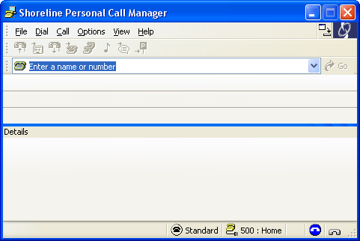

Figure 16. PCM appearance when logic succeeds

When CSIS login fails, the status bar will not show any call handling mode, handsfree mode, or extension location information. If the user belongs to a workgroup, login status will not be shown either. Also, note that the title bar will show the generic “Shoreline Call Manager” rather than showing the client type. Also, some options of the “Options” menu will be grayed out. CSIS also shows an icon in the system tray whenever the CSIS connection between client and server is broken – see figure 17b.
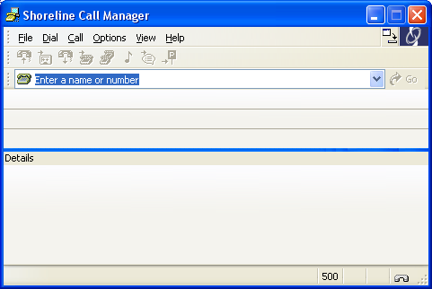

Figure 17a. PCM appearance when CSIS login fails. Note lack of Call Handling mode, Handsfree Mode, and Extension Location on status bar.

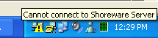

Figure 17b. System tray icon for CSIS disconnect

How to troubleshoot login problems

If one of the Call Manager applications does not login successfully, here is what you should do:

1) Test the CSIS Server

First, test that the CSIS server is up and running in the first place. You can do this by pasting in the following URL in your browser, and changing [servernameoripaddress] to the name of the server you are trying to connect to:

< http://servernameoripaddress/CSIS/CSISISAPI.dll/?request?;CCSISSvrCONN::ping;>

The result will be shown in the browser window and should look something like this:

10;0x00000000;4;5440

The second field is the return code from the ping – zero is good, anything else is bad! The fourth field is the port number that CSIS is running on – this defaults to 80 on Goleta Beach and 5440 on Iona Beach and higher (build 6.3.3400.0 and higher). At the time of writing, these ports are set by the installer and not end-user configurable.

The first and third fields simply indicate the length of the second and forth fields…

2) Check the login parameters. The easiest way to do this is the following:

- Go to “Phone and Modem Options” (Win2000 or higher) or “Telephony” (legacy versions of Windows) in the Windows Control Panel.
- Go to the “Advanced” tab. Select “Shoreline Remote TAPI Service Provider” (see Figure 18. Will look somewhat different under legacy versions of Windows)
- Hit the “Configure” button
- You will see the screen in Figure 19.
- If the server name and/or user name are incorrect, do the following:
  - Under “Provider Usage”, select “Do not use this service provider (disable)”
  - Hit “Apply”
  - Modify the server name and user name to the correct values
  - Under “Provider Usage”, select “Use this service provider (enable)”
  - Hit “Apply”
  - Exit all Shoreline applications (make sure CSISCMgr.exe exits. If it doesn’t, log off Windows. If you are unsure, log off Windows).

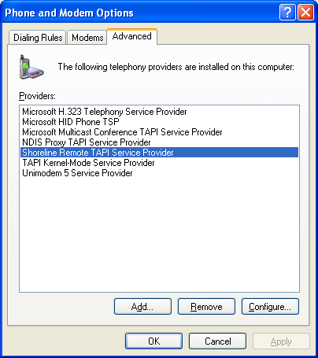

Figure 18 Phone and Modem Options, Advanced tab

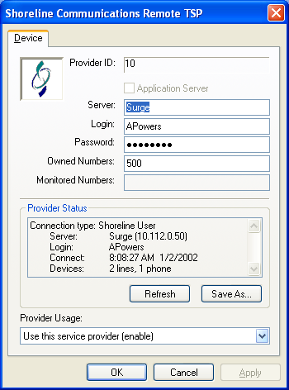

Figure 19. Remote TSP Configuration screen

3) Make sure there are no Shoreline applications that are still running but not showing any windows. This would be indicated by the presence of any of the following processes running on the computer:

- STCHost.exe
- STMapiRd.exe
- CSISCMgr.exe

If any of the three are running, please kill each one off, in the order given above, and wait a couple of seconds. Then try again.

4) Engineering Help

If you require Engineering help with CSIS or Agent.exe, please go directly to Ken Robesky.

Telephony Problems

Problems include:

- On hook / Off hook indicator not reflecting reality
- No call displayed when you receive an incoming call
- Can’t place outgoing call
- Nonexistent call displayed in client
- Can’t perform operation such as transfer on existing call

Diagnostic Procedures:

First, find out whether TAPI is working or not. There are several applications that you can use.

- TAPITEST.EXE

TAPITEST.EXE is a Shoreline diagnostic application that displays information about the Shoreline line and phone devices available on the system. The program can be copied from the Build tree \\toast\allbuilds\ib\6.x.xxxx.0\Release\TapiTest.exe and will be on the client CD.

Simply run the tool. It will produce output showing the line and phone devices, something like this:

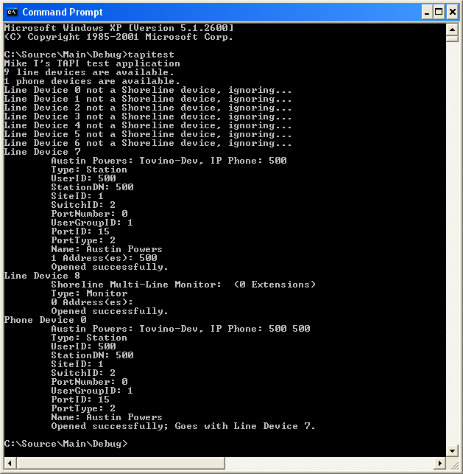

If you don’t see a line device with the user’s stats on it, you’ve got TAPI problems.

- Windows Phone Dialer

Start the Windows phone dialer (dialer.exe). Choose Connect Using… from the Tools menu. If there are no entries in the “Line” drop-down then (or all the entries are modems or other locally-installed telephony devices) the Remote TSP is not working or TMS is not functioning.

If the drop-down has entries, check to make sure one of the entries matches the user’s switch port and extension. If there is no entry matching the user’s extension then the Remote TSP is not properly configured. It can be reconfigured using the Telephony Applet in the Windows Control Panel. This probably indicates a problem that should be examined by engineering.

If the user’s entry is found, select it. Try to place a phone call using the dialer. If that fails, it means TAPI is partially functional but not fully functional. See Appendix A for more information on using Phone Dialer to determine the cause of problems.

If all of these tests succeed, then TAPI is not the culprit, PCM is. Restarting PCM should solve the problem at this point, but engineering should be notified as this represents a problem.

Caller ID Problems

Problems include:

- Call is displayed, but Caller ID name and/or number is not correctly displayed.
- Names and numbers in routing slips don’t match what’s in the call display

This can happen due to problems in any of the following layers of the system:

PCM
RTSP
TMS
Switch firmware

It can also happen because we receive bad data from the Central Office on incoming calls.

In order to determine if the problem is with PCM or lies below PCM, one should use another TAPI application, such as Phone Dialer or TB20 to check the Connected ID Name and Number. The number should match what you see in PCM. (Remember, PCM may apply formatting rules on the number!) and the name should match…. Unless, that is, the user has a name that matches the number in their System Directory, Personal Directory, or Outlook contacts.

TB20, by the way, is a low-level TAPI application that can be used by engineers to examine the system’s response to TAPI function calls. It is intended for use by developers only so I will not discuss it here. Members of the engineering team who are familiar with TAPI (Mike Tovino, Scott Van Gundy, Kishore Nadimpalli) should be able to assist if necessary.

General problems with a particular call

One can use PCM do collect information about any particular call, and this information can be used to reference the call in the TMS (or, in Iona Beach and beyond, the IPDS logs). See appendix C for information on collecting call information.

Occasionally you may see an error icon on a given call, as such:

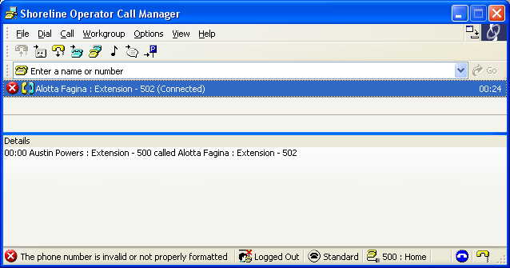

The error message is shown on the title bar in these cases. In this instance, the user tried to transfer a call to a non-existant extension. More error information is included in the Call Properties dialog:

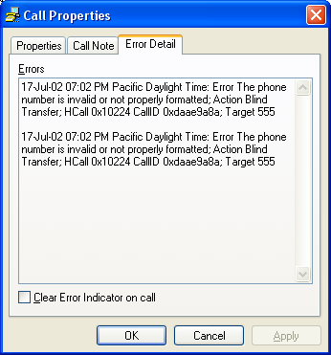

and also in the PCM log.

Configuration Change Problems

Problems include:

- “Server Unavailable” message when you try to change call handling or headset mode
- Unable to use Options / Shoreline Config or the Shoreline System applet in the Windows Control Panel
- Call Handling Mode or Headset Mode display on PCM does out of sync with reality

Diagnostics:

See the section on Login problems, as much of the information there applies. First, make sure the CSIS server is still running using the URL provided in the login section.. If it is, make sure that CSISCMgr.exe is still running on the client PC. If yes, then try changing hands free mode back and forth or changing call handling modes, and see if that works.

You can find out if PCM thinks it is connected to the CSIS server by putting the cursor in the QuickDialer and hitting Ctrl+F12. This will produce a diagnostics dialog, see Appendix B.

MAPI Contact Import problems

You can troubleshoot MAPI contact import problems by using the MAPI debug flags or by running SHAdrTst.exe which is included on the client CD.

To set the MAPI debug flags use the Ctrl+F12 dialog as described in Appendix B. The MAPIRD log will contain more information that you’ll ever need with the proper debug flags set.

Simply running

SHAdrTst

from a command prompt lists out what will be imported by Personal Call Manager. If you wish to dump the output to a file, use

SHAdrTst > filename.txt.

If you want to include debugging statements in the output (you probably want to do this) use

SHAdrTst –stdout -debug

or

SHAdrTst –stdout –debug > filename.txt.

(Of course, filename.txt can be anything you want).

I recommend that you dump the output to a file as in the second and fourth examples and send the output files to me.

The output will contain a listing of all data that will be imported by Personal Call Manager. It will be useful for further analysis by engineering.

History File

PCM stores history in a text file called History.txt. On Windows 2000 or higher, the file will be located in <user app data>\ShoreWare Client\<username>,

e,g.

C:\Documents and Settings\mtovino\Application Data\ShoreWare Client\Mtovino\history.txt

On other platforms the file will be found in <client install>\<username>,

e.g.

C:\Program Files\Shoreline Communications\ShoreWare Client\Mtovino\History.txt

The file is simply tab-delimited text, so you can open it in Excel and view it as well.

Log Files

PCM logs all unexpected errors, exceptions, and warnings to a collection of files. The main log file is named logfilename-MMDDYY.log where logfilename is from the table below literal and MMDDYY represent the month, day and year (e.g. CC-071702.log) and can be found in <app data>\ShoreWare Client\Logs on Windows 2000 or <install dir>\Logs on other platforms (See history file for examples).

Log file name Contents
CC Basic client log
CX stack traces from any exceptions encountered
MAPIRD Mapi import process (StMapiRd.exe)

Even without any debug flags set, all events coming from CSIS and TAPI are logged to the log files. Also, all unexpected errors are logged to the error logs. This can be changed by placing the cursor in the QuickDialer window and hitting Ctrl+F12. (See appendix B for more information). Check the boxes for the type of logging you want done. Please use your head when selecting additional debugging information and select only what you need to capture the problem at hand. Otherwsie logs can fill up (cauing information to be lost) or get so big that it takes me forever to analyze them.

You can preset all debug flags by running the command line “StartCli.exe –d” instead of the usual “StartCli.exe”.

If you want to get logs from a customer, you can instruct them to use the SendLogs utility. Have the customer go to their start menu, and navigate to Programs/Shoreline Communications/Support/Send Client Logs and select it. It opens up a wizard, simply follow the instructions.

Sample screen from the wizard:

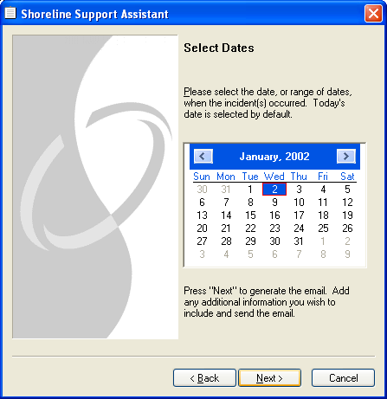

Appendix

A. Checking TAPI Configuration with Phone Dialer

Win95 98, NT4

- Open Phone Dialer from Start/Programs/Accessories or Start /Programs/Accessories/Communications

- Choose “Connect Using” from the “Tools” menu.

- Select the row in the Line dropdown that corresponds to your extension. It should be identified by your name, the name of your switch, and the port number on that switch as shown below. (The word “Phone” simply indicates that there is a phone device associated with your line). If there are no items in the Line drop-down or you get an error message, TAPI is malfunctioning, and PCM will not be able to work properly until this is fixed.

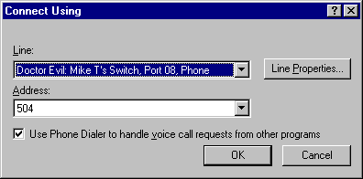

- The address should match your extension number. If it does not, select your extension. If it is not available, you’ve located a problem – fix it by logging into Director and changing the extension for the user in question.
- Now hit OK.
- Try to dial another extension on the system using the dialer window, as shown below.

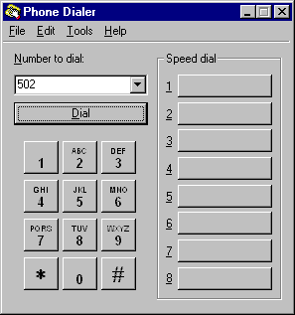

- PCM should succeed or fail the same as the phone dialer. If phone dialer succeeds and PCM fails, PCM is the culprit, otherwise you probably have a TAPI problem.

Win 2000 or higher

- Start the phone dialer, from Start/Programs/Accessories/Communications
- Select “Directories” in the left pane, as shown below.

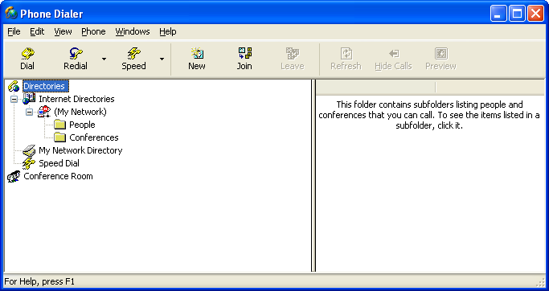

- Choose “Options” from the “edit” menu. Set “Preferred Line For Calling” to “Phone” and select your line from the “Phone Calls” drop-down in the “Lines Used For” group. Lines are identified the same way as in the Win 95/98/NT4 phone dialer.

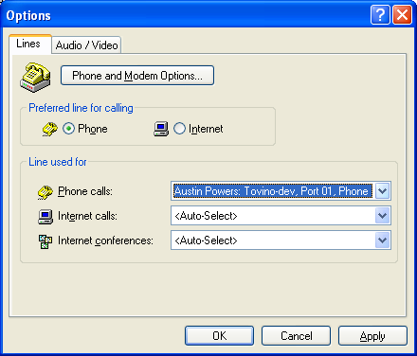

- If anything has gone wrong up till this point, your problem is a TAPI problem. Othwerwise, hit OK.
- Click the dial button, which opens this dialog:

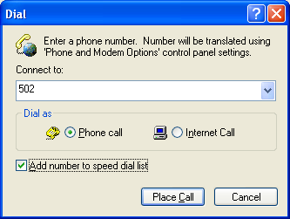

- Enter a valid phone number and place the call. If it works TAPI is OK, and PCM is the problem. Otherwise, TAPI is misconfigured or broken.

B. Getting more diagnostic info from PCM

Place the cursor in the QuickDialer field and hit CTRL+F12. You will see the dialog shown in Figure 20 - 22. (From Queue Monitor, Extension Monitor, or Agent Monitor, simply hit Ctrl+F12 when the cursor is not on any call.)

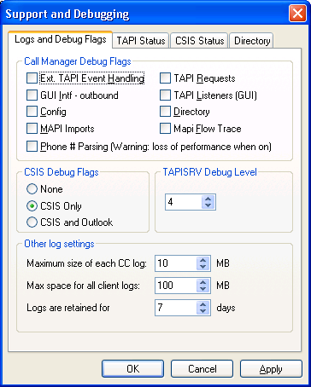

Figure 20. Support/debugging dialog, logging tab

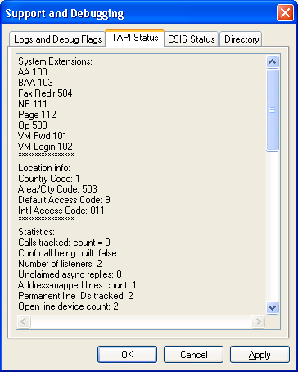

Figure 21. Support/debugging dialog, TAPI tab

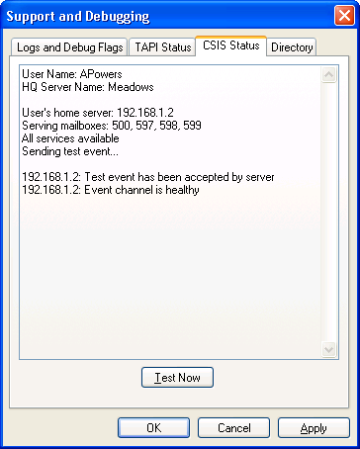

Figure 22. Support/debugging dialog, CSIS tab

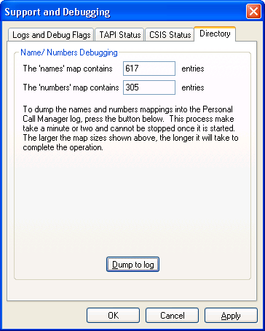

Figure 23: Support/debugging dialog, Directory tab

This dialog is not available through any menu or other published or documented means. It is meant to be used by Shoreline only. This dialog gets updated in almost every release. The information here is correct for Iona Beach, there are slight differences for other releases.

The first group box allows you to set debugging options, these will be discussed soon. The second shows you information about the status of the CSIS server connection. The third group box show TAPI diagnostic information. The information in this dialog is always written to the CC log when the dialog is opened.

Call ManagerDebug Flags

Here is what each of the debug flags do. Also included are the codes to specify them from the command line:

Extended TAPI Event Handling – traces extended information on what the Call Manager’s TAPI layer does with raw TAPI events. Includes some name/number formatting. Number code: 256. Letter code: h

TAPI requests – traces calls made from the client’s TAPI layer to TAPI itself. Number code: 2 Letter code: r

GUI Interface Outbound – traces functions calls made from the UI components to the client’s TAPI layer Number code: 1 Letter code: i

TAPI Listeners (GUI) – traces what the TAPI layer forwards to the UI layer when it processes TAPI events. Number code: 8. Letter code: l

Config – traces interactions with CSIS. Number code: 16. Letter code: c

Directory – traces interactions with MAPI and the Address Book portion of CSIS. Number code: 32. Letter code: d

Mapi Imports – traces the names/number pairs of all contacts and address book entries imported via MAPI Number code: 512. Letter code: m

Mapi Flow – traces the step –by-step search through one’s MAPI profile in search of contacts and address book entries. Number code: 1024. Letter code: f

Phone # Parsing – traces each attempt to parse a string into a phone number. Turning this flag on can severely impact the performance of all Call Manager applications, and can fill up a disk with log files very quickly. Use with discretion! Number code: 128. Letter code: p

In general, if you are tracking a telephony issue, set all of the first 5 debug flags. Checking the “Save debug flags” check box will make the debug flags persist across client restarts; otherwise, changes to the debug flags are lost when you exit.

To specify debug flags on the command line, you would either add the number codes of all the flags you want or combine the latter flags. Examples: to run Call Manager with Config and Directory flags on, you could use either of the following:

StartCli –cm –d 48
StartCli –cm –d cd

(Note that in the first case, 48 is 32 + 16 and not 4 combined with 8)

CSIS Flags

There are three choices for CSIS debug flags, and their registry (HKCU\SoftWare\Shoreline Communications\CSIS Client\DebugFlags) equivalents:

None (“”)

CSIS Only (REDIR:3;CSIS) – turns on general CSIS tracing

CSIS and Outlook (REDIR:3;CSIS;Outlook) – turns on general CSIS tracing plus CSIS tracing related to Outlook

TAPISRV Debug Level

It’s a number between 1 and 7; see Kishore for the proper setting for a given situation. This is stored in HKEY_LOCAL_MACHINE, so users that don’t have admin privileges on the machine will not be able to modify this value.

Other Log Settings

There are three values that are configurable here.

Maximum size for a single CC log – CC logs will automatically cut themselves off if they reach this limit.

Maximum Space for All Client Logs – CSIS cleans up the C:\Documents and Settings\username\Application Data\ShoreWare Client\Logs directory once a day. It will make sure the total size of all files in that directory is less than the total size given here

Days retention – logs old than the given number of days are deleted.

CSIS Connection information

This are shows which server CSIS is connected to (or trying to connect to), which user it is connecting as, and what the client-side interface thinks about the connection state.

“Connection Status” indicates whether or not the client thinks its CSIS connection is alive at the moment. “Event Channel Status” tells whether or not it can send a test request to the server and get an event back.

If “Connection Status” is “Not Connected”, then it is likely that any CSIS-related requests would fail. If “Event Channel Status” is not healthy, but “Connection Status” s connected, then it is possible that requests made by the client are being fulfilled (such as a request to change call handling mode) but the client is not being notified when these (or other) changes are completed.

TAPI information

There is quite a bit of information in this area. It is divided up into sections.

- System Extensions – Tells where Call Manager apps think each of the system and site extensions point to.
- Location Info: Tells which country code, area code, and default trunk access code the Call Manager is using. This information is derived from the user’s current Site and Default Trunk Group. If the user is on SoftSwitch, the site will be HQ. Also, shows the international access code that will be used to dial out of the user’s country code. This is done via lookup table.
- Statistics: This is some technical information that refers to the Call Manager’s TAPI engine, NOT the Remote TSP or TAPI itself. This will make sense to me only, but it is very useful for debugging strange situations like calls not showing up or calls that don’t really exist showing up.
- User’s Extension: Shows some of the TAPI values relating to the user’s extension. If HLine is zero, then something is wrong, either with the configuration of PCM, the Remote TSP itself or TMS.
- Device Mappings: Shows some basic information about all line devices detected on the system that are exposed to TAPI 2.0 and higher. The PType variable indicates whether the device is a Shoreline device; PType 1 and 2 are Shoreline. Unless there is either a ShoreWare server installed on the PC or multiple instances of the Remote TSP (in a field environment, this would be a custom job) there should be exactly two entries: One for the user’s extension, and one for the multiline monitor. If the user has the Personal client type, the MLM should not be monitoring anything. If the user has an Advanced, Operator, or WG client type, then the MLM device may be monitoring additional extensions. The extensions are called “Addresses” in TAPI and in this display.
- Listeners: Shows all UI-level features and applications that are interacting with the TAPI engine, and which extensions they are monitoring for call activity and for device activity. (For TAPI enthusiasts, Device activity consists of Phone events and non-call related Line events – in other words, things that affect the Off Hook/On Hook indicator in PCM).
- Calls tracked: Shows information about each call currently being tracked by the Call Manager’s tapi layer. The call handle, call ID and call GUID are shown; also the two parties on the call separated by a < or > sign to indicate direction. (The party on the left is the extension the call is reported on; if both parties of a call are being monitored then the call will appear twice). Also, the last TAPI call state event is reported including the time it was received. (Note: in Goleta Beach, only the call handle and parties are given).

Appendix C: Collecting call IDs/GUIDs on individual calls

PCM can be used to collect the Call ID and GUID (Iona Beach and later) on individual calls. This can be done for any call that is currently displayed in the Personal Call Manager, Extension Monitor, Agent Monitor, or Queue Monitor; and also any call displayed in the History Viewer. Figure 21 shows the dialog. (Note that the Call GUID, which was introduced with ShoreSip in Iona Beach, is not present in Goleta Beach).

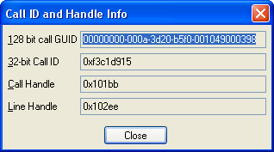
Figure 24. Call ID and handle dialog

The information in this dialog can be used as such:

Call GUID: tracking calls in TMS, IPDS, Switch logs
Call ID: tracking calls in TMS, Switch logs (Goleta Beach)
Call Handle, Line Handle: tracking calls in PCM logs w/ debug flags on

For each window, here is how to collect the information:

Personal Call Manager

- Select the call you want information on (Figure 22)
- Invoke “Call Properties” on the call from the menu
- Place the cursor in the 1st edit box (Figure 23)
- Hit Ctrl+F12

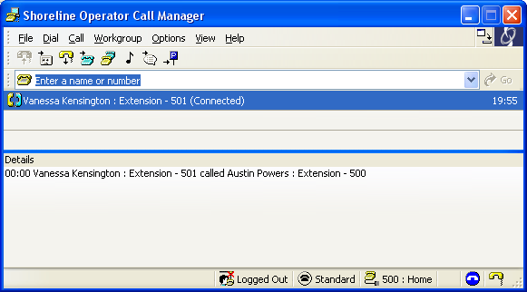
Figure 25. Call selected

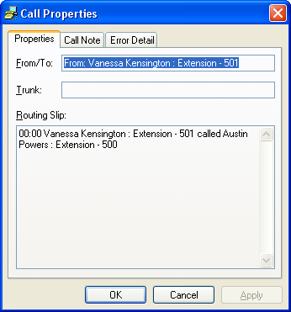
Figure 26. Cursor in 1st edit control

Extension Monitor / Agent Monitor

- Select the extension where the call is in Ext/Agent Mon. (Figure 24)
- Choose “Properties” from the “extension” menu
- Select the call you are interested in (Figure 25)
- Right-click and choose “Properties” on the call
- Place the cursor in the 1st edit box (Figure 23)
- Hit Ctrl+F12

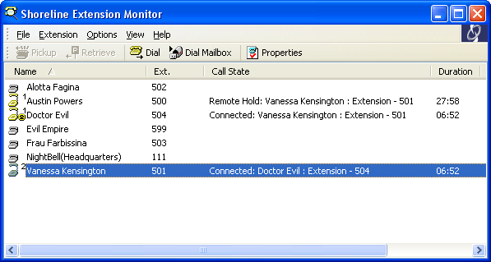
Figure 27. Select the extension

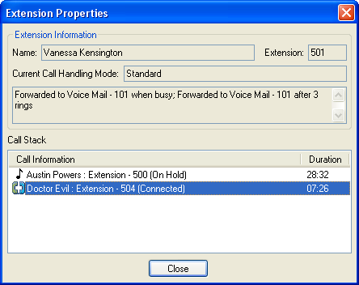
Figure 28. Select the call

Queue Monitor

- Select the call in question (must be in large view – figure 26)
- Hit Ctrl+F12

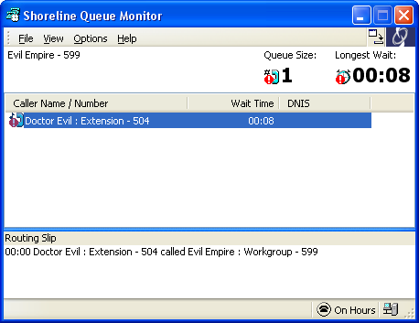
Figure 29 – select the call

History Viewer

- Select the call (Figure 27)
- Place the cursor in the 1st edit box (Figure 23)
- Hit Ctrl+F12

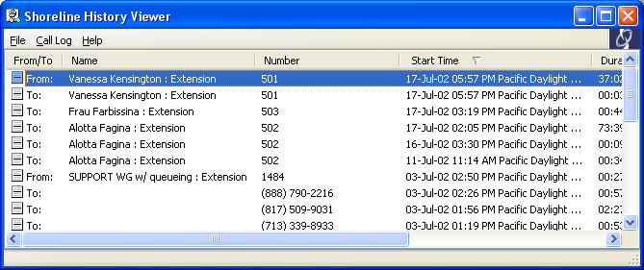
Figure 30 – select the call

Appendix D: Checklist for data collection when reporting a bug

Here is a checklist of things you should do every single time you are reporting a bug or collection a bug report from a customer. Naturally, not all the things on this list will help us with very bug, but by doing them all, you increase the chance that the problem can be found without bothering the customer with follow-up requests.

- First, place the cursor in the QuickDialer field on PCM and hit Ctrl+F12. The visible feedback is that the Debug level dialog is raised (see appendix B). More important, a bunch of diagnostics are dumped into the CC log. These diagnostics are described in Appendix B and give an overview of the client’s state at the tie of the Ctrl+F12.
  - Set any debug flags appropriate for the bug being reported. Please use your head here. If you are reporting a call-related bug, include the TAPI flags. If you are reporting a configuration issue (call handling modes not being set, etc) include the Config flag.
  - If you are working on any type of call related problem, please set the TAPISRV debug flag to 3 or higher. This is included in the CTRL+F12 dialog on recent builds of GB and higher. If it does not appear here, set it manually in the registry: HKLM\Software\Shoreline Teleworks\Telephony Management Server\Settings\TapiSrvDebugLevel (DWORD value)
  - On Kona Beach and higher, if the problem is related to number/name lookups or contact import, use the “Dump to log” button on the Directory tab
- Take screenshots of any visible problems that are being reported by the customer. If possible, the screenshots should be saved as JPEGS to conserve disk space and bandwidth. If this is not possible, please save as BMP files (e.g., using MS Paint) and then zip the files. Please do not imbed the screenshots in Word docs. This increases file size and loses clarity of the image.
- Have the user do a SendLogs (Start Menu, Shoreline, Support, Send Client logs). The user can add the screenshots taken in step 2 as attachments to the Send Logs email.
  - Please make sure that the TAPISRV log is collected. If it is not (which happens in some of the versions of GB that are out there) it can be manually attached; usually it is in C:\Program Files\ Shoreline Communications\ShoreWare Client\Logs
- Using the techniques in Appendix C, collect the Call ID of each troublesome call.
- When you’ve received the logs and screenshots, zip them together in a single ZIP file and attach to the SR or bug.

As always, make sure you get a detailed description of what happened!

In addition to the steps above, you may want to set certain debug flags to catch the problem later, or set certain debug flags, reproduce the problem again, and do a second Ctrl+F12 to dump the results to the log. (Don’t forget to collect the 2nd set of logs if you do this!) See Appendix B for more info on the specific debug flags.

Appendix E: Version / Release translator

Internal name Build # range Marketed name

Kona Beach 8.x.x.x Shoreline 4 Release 3
Jamaica Bay 7.x.x.x Shoreline 4 Release 2
Iona Beach 6.x.x.x Shoreline 4 Release 1
Goleta Beach 5.5..x.x Shoreline 3 Release 4

Appendix F: Running PCM on a Windows Terminal Server

The client version of the Remote TAPI service provider does not work properly on Windows Terminal Server. In order to run it you need to do a few manual steps. Here they are:

1) Install ShoreWare client as normal

2) Reboot if requested

3) Go to the Windows control Panel, Phone and Modem Options, Advanced tab.

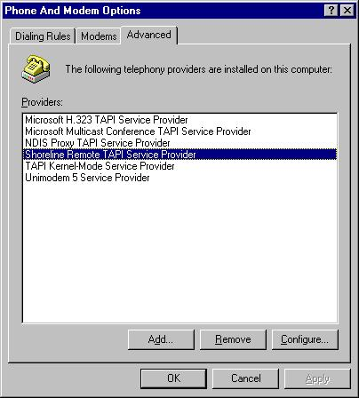

Figure 31 – Phone and Modem Options, Advanced tab

- For each “Shoreline Remote TAPI Service Provider” instance, click “Configure”.

If it looks like Figure 32 – showing error messages and general lack of function - hit Cancel, and the Remove from the screen shown in Figure 31.

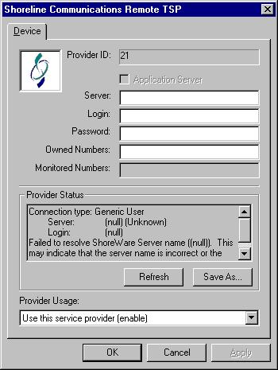

Figure 32 – non-functioning client RTSP under Terminal Server

If it looks like figure 33 – shows connection to a ShoreWare Server and lots of phone / line devices, leave it alone and proceed to the next one.

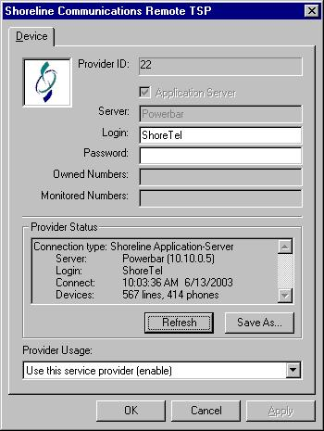

Figure 33 – functioning server TSP

5. After you have performed step 4 on each of the original Shoreline TSP entries, you should be left with either no Shoreline TSP entries at all, or one functioning Server TSP entry. If you have one server TSP entry, you’re done. Otherwise proceed to step 6.

6. At this point you should have no Shoreline TSP entries left – if there are any remove them. Close the Phone and Modem Options dialog (important – if you don’t close it, the rest of this step will not work) Now, obtain a copy of TSPInstall.exe. This will be included on the Server CD in the near future; as of build 8.2.3100.0, it does not get included on the server CD, please contact engineering for a copy. Run it from the command line as shown in Figure 34. (Don’t forget to substitute the correct HQ server name for “Powerbar”).

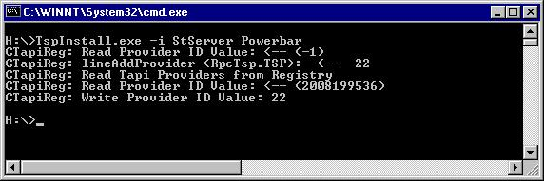

Figure 34. TSPInstall command line

7. Now reopen the Phone and Modem Options dialog (Figure 31) and click “Configure” on the newly installed Shoreline RTSP. If it does not show a good connection and an appropriate number of phone and line devices hit “Refresh” a few times. If that doesn’t work, Disable and the Enable it, hitting Apply at each step along the way.

8. You should be ready to roll at this point!

I’ve been told the same steps work on Citrix servers as well, although I’ve never personally tried this. (If you know of a Citrix server I could access to try it, let me know!)

