Force Shoretel Scripts to run at Shutdown and Startup

- Open command prompt and type: gpedit.msc

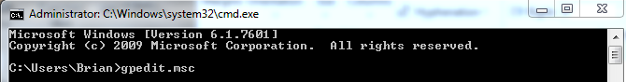

- After the ‘Local Group Policy Editor’ window opens, expand ‘Windows Settings’ and select ‘Scripts (Startup/Shutdown)’

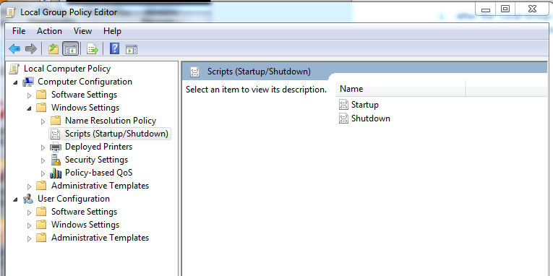

- Select Startup and go to Properties.
- In the ‘Startup Properties’ window, choose ‘Add’
- Browse to C:\Program Files X86\ShorelineCommunications\ShorewareServer\Scripts
- Enter hq_shoretel-start-svc for the Startup and hq_shoretel-stop-svc for the Shutdown

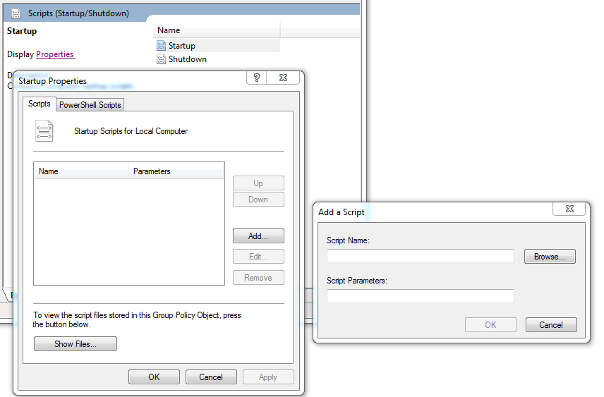

- The ‘Script Parameters’ can remain blank

Now, when the server is shutdown, Windows will run the ‘Shutdown’ script. The script will disable all Shoretel services and set the ‘Startup Type’ of each service to ‘Manual’.

When the server is first started, the Shoretel services will initially be set to Manual.
Then, Windows will initiate the ‘Startup’ script and all Shoretel services will start.

