Title: | DCOM Errors and Kadota Util permission required
Category:
Technical Note Number:
Release Date:
Products Affected: | Hardware: |  | Software:
 | SG-8: | SG-12: |  | ST4, r3:
 | SG-24: | SG-T1: | ShoreTel5, R1.1:  ShoreTel5, R1.2:  (Contact ShoreTel support before attempting on any versions not listed above!)
 | SG-E1: |  | ShoreTel Converged  Conference Bridge:
 | Teleworker: | IP Phones:

Repairing most DCOM errors

**Please read this entire document before starting on the steps provided. This **document goes over numerous methods of repair and your issue might be resolved **by one of any of these methods.

Most DCOM errors are caused when the permissions assigned to the DCOM object that is needed by the system to function have not properly been set up for whatever reason.

This document will try to guide you through the process of correcting most DCOM errors that you happen across however, in certain circumstances it may still be required that you call Technical Services to assist you through the DCOM errors that are not corrected here.

There is a previous Tech Note that goes over “Object Required” from an initial installation point of view. This document should be read and followed prior to going over the suggestions here.

Please note that if all these steps are taken and you still get a Kadota UTIL permission denied error, the problem may be that the IP address of the server has been changed and the Shoreware Database is still reflecting an IP address that is not set on the NIC. (When a server is preconfigured and then sent to the customer location. This issue happens more often than not and even though you may have thought that you checked this, a recheck would be a great way to start. )

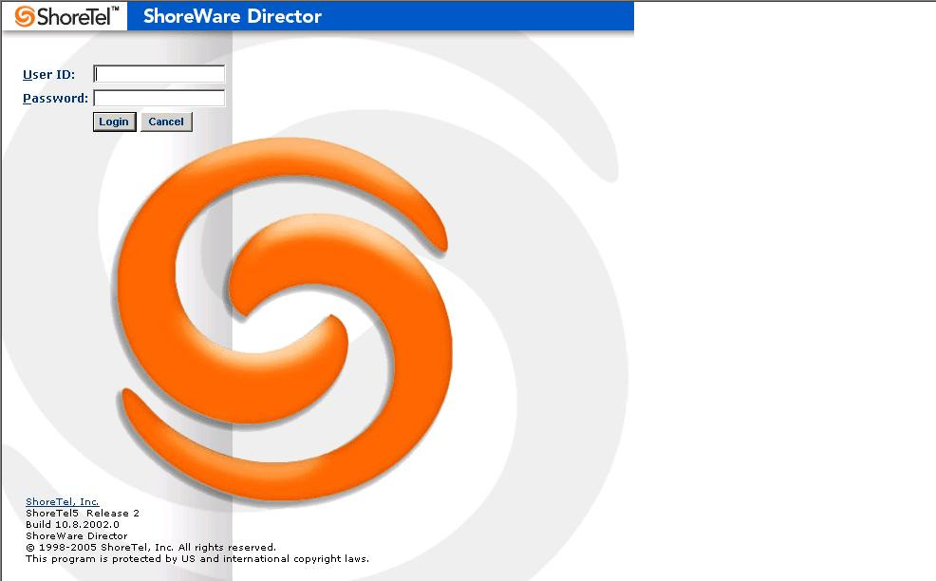

Initial login screen for ShoreTel Director.



Error screen that appears
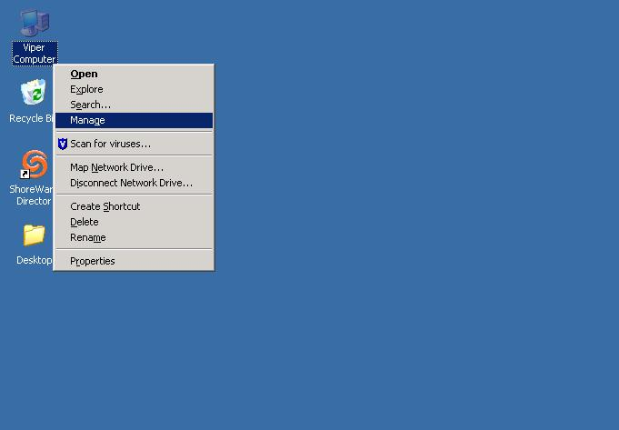

View the entries in the Event Viewer log.

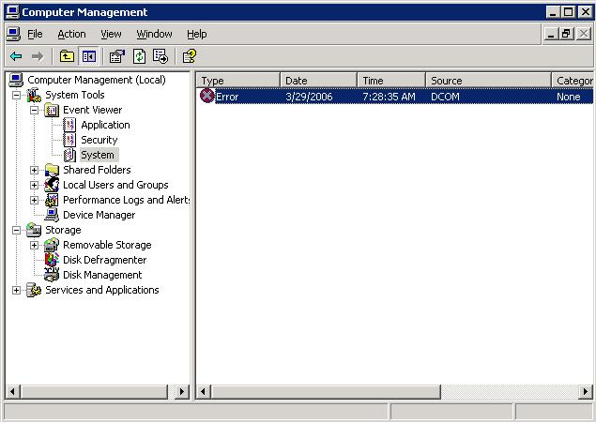

The DCOM errors may be further down in the log, you will want to try and locate this event for the required information Notice the DCOM error under System log.

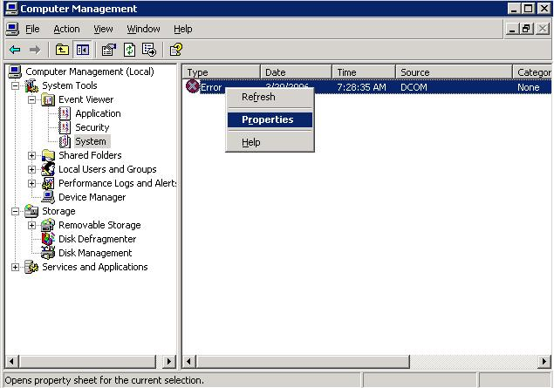

Right Click on the Event then left click on properties.

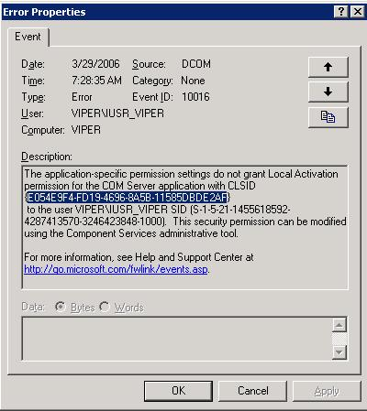

Within the properties you will want to find the CLSID.
HIGHLIGHT the CLSID and then hit “Ctrl + C” for copy you can not and do not want to do a copy using the mousse right button because in this situation it will not work.

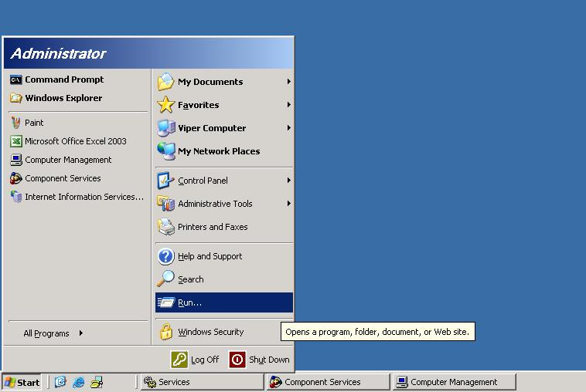

Now Click on START and then go to RUN and type regedit. The registry editor will then be presented.

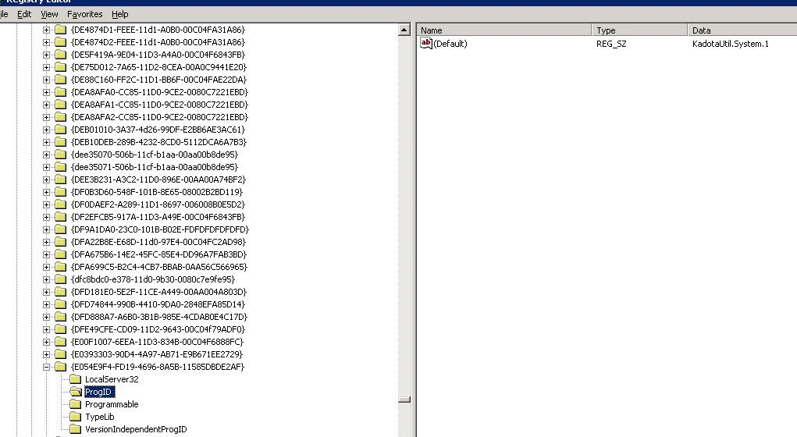

Once the Registry editor is open Click on My Computer at the tope of the list and then go to EDIT and then click on FIND. Now, paste the previously copied document into the find field and then click on “Find Next” Once presented with your search results click on “ProgID” and in the right panel you will see which program is unable to operate properly due to insufficient permissions.

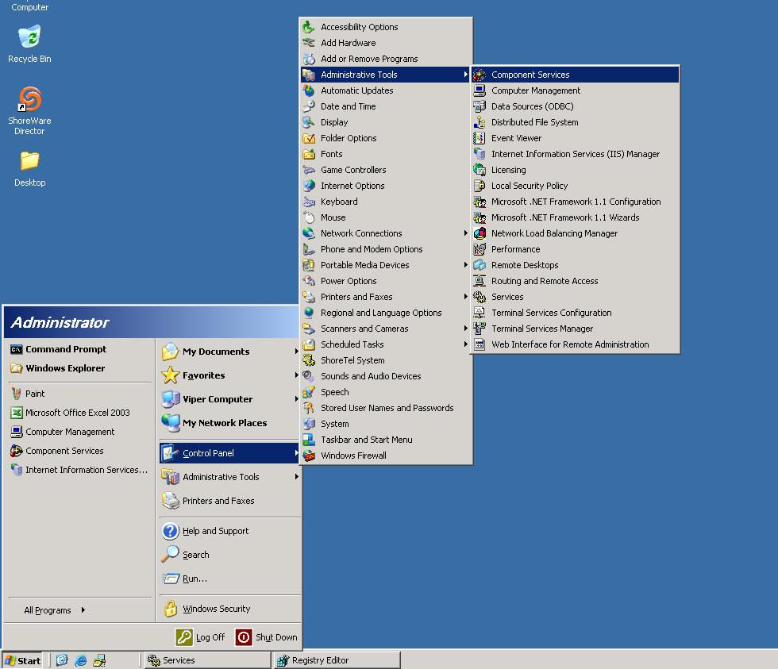

Now that you have found which program is at fault , click on START-CONTROL PANEL – ADMINISTRATIVE TOOLS – COMPONENT SERVICES.

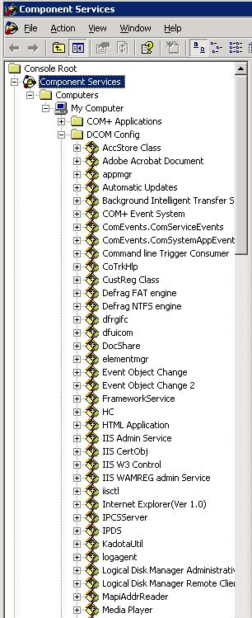

Click on COMPONENET SERVICES – COMPUTERS – MY COMPUTER – DCOM CONFIG – now find that program that was previously identified in the registry search.

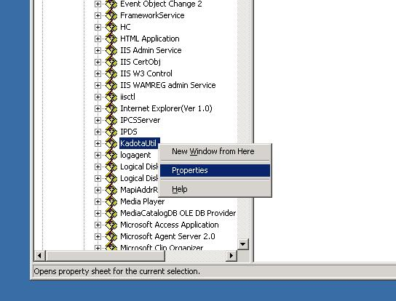

Right Click and go to Properties and left Click

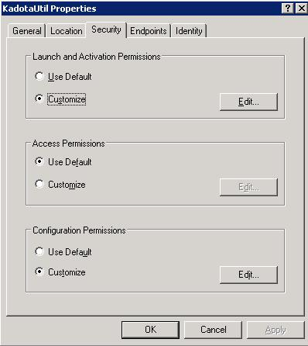

Click on Security and make sure that the USE DEFAULT selection is Chosen for all Permissions.
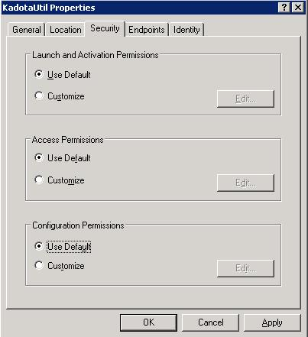

Confirm that all options are set to USE DEFAULT.

