## Mobile App User Guide

### Quick Links

Click link to jump to section.

1. [Install](https://www.corenexa.com/corenexa-mobile-user-guide-ios#install)
2. [Login](https://www.corenexa.com/corenexa-mobile-user-guide-ios#login)
3. [Navigating Around the App](https://www.corenexa.com/corenexa-mobile-user-guide-ios#navigation)
4. [Landing Screen](https://www.corenexa.com/corenexa-mobile-user-guide-ios#landingScreen)
5. [Dialpad](https://www.corenexa.com/corenexa-mobile-user-guide-ios#dialpad)
6. [Recent Calls](https://www.corenexa.com/corenexa-mobile-user-guide-ios#recent-calls)
7. [Contacts](https://www.corenexa.com/corenexa-mobile-user-guide-ios#contacts)
8. [Search](https://www.corenexa.com/corenexa-mobile-user-guide-ios#search)
9. [Voicemail](https://www.corenexa.com/corenexa-mobile-user-guide-ios#voicemail)
10. [Conference Calls](https://www.corenexa.com/corenexa-mobile-user-guide-ios#conference-calls)
11. [Virtual Attendant](https://www.corenexa.com/corenexa-mobile-user-guide-ios#virtual-attendant)

1. [Settings](https://www.corenexa.com/corenexa-mobile-user-guide-ios" \l "settings)

Install   
There are 2 ways to install the CoreNexa Mobile App:

Using UC Client:

1. Under the Applications Module, select Mobile Download.
2. Scan the code using a QR Reader on your mobile device.

### corenexa-download-android

### Directly from the App Store or Google Play Store

### Download the CoreNexa™ Mobile app from the Google Play store.

### Follow the instructions to install.

### google-play-store-logo

### Login

Once the app is installed on your device:

1. Tap the CoreNexa Mobile icon
2. On the sign in screen there are 2 ways to sign in:  
   1. Enter your username & password
   2. Scan the QR code in UC Client

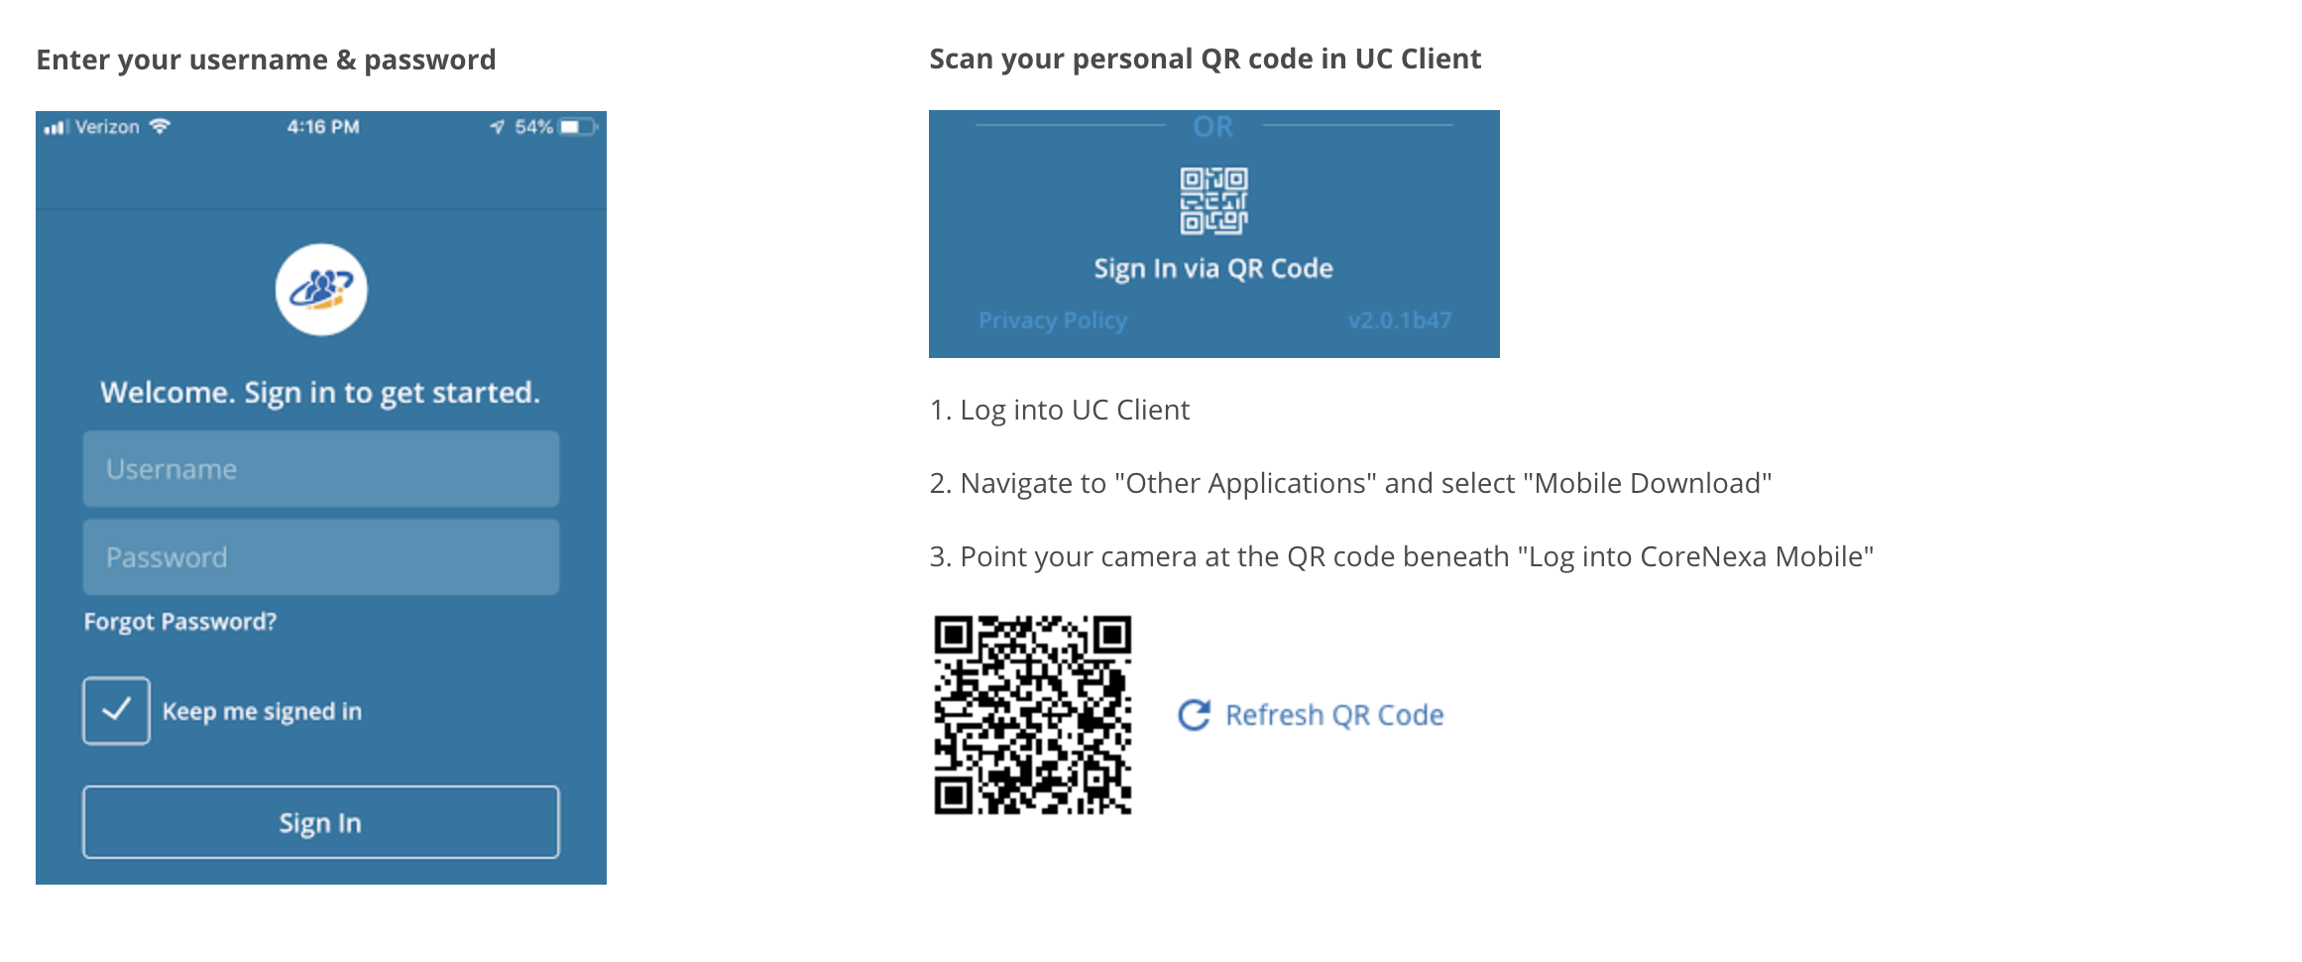

Navigating Around the App  
The main screen is the list of menu options that provide all the functionality of the app.  
  
As you click into each menu item, click on the menu icon corenexa-menu-icon to be taken back to the   
main menu.

### Landing Screen

Once logged in for the first time the app will land you on the default landing screen on the Dialpad. Subsequent visits will take you to the last menu option that you closed the app on.

From the landing screen you can perform the following:

* Make a call
* View your Call History
* View/edit your contacts
* Search by name, phone number or extension

### dialpad-androidDialpad

### Use the dialpad to place calls.

1. The following actions are available while on a call:
   1. Mute
   2. Dialpad
   3. Audio - switch between microphone,   
      speaker and connected bluetooth devices
   4. Hold
   5. Record (if purchased)
   6. Transfer

Audio  
While on an active call you can switch between microphone, speaker and connected   
bluetooth devices.

To switch press the audio button and select which option you want to use by pressing   
that option

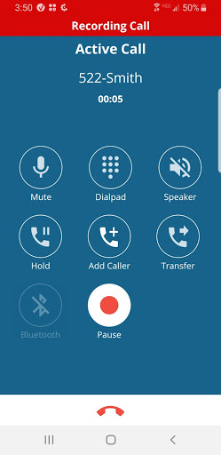 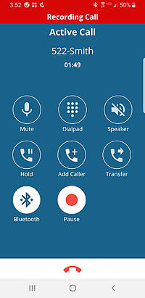

Call Waiting  
While on an active call you have the ability to receive a second inbound call. When the call arrives, you will be presented with a screen to make the following selection

* Hold & Accept
* End & Accept
* Decline

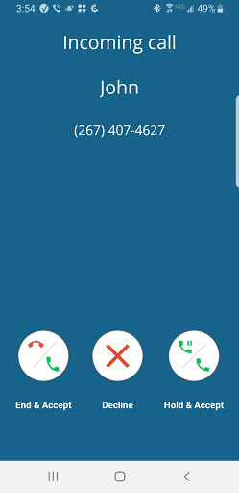

### 

### 

### 

### 

### Recent Calls

Recent calls provides a view of all incoming, outgoing, and missed calls.

At the top of the screen there are two tabs: All & Missed.

* All will display all types of call activity.
* Missed will provide only missed calls.

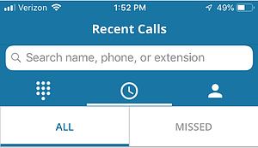

Each entry will provide the following:

* Direction of call
* Name / Number
* Date & time
* Ability to call
* Ability to create contact (if not already a contact)

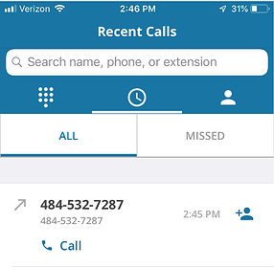

Contacts  
Contacts are organized under 4 tabs:

* Favorites
* Corporate
* Personal
* Local

1. To favorite a contact, click on the contact entry and select the Favorite icon corenexa-favorite-contact
2. To share a contact, click on the contact entry and select the Share icon corenexa-share-contact
3. To call a contact directly from the contact entry, press the phone icon corenexa-call-contact

### 

### 

### 

### 

### 

### Search Search through your Contacts and Recent Calls by Name, Company name, Phone number or Extension. Start typing and all matches will appear.

For example, if you type in John, then all matches that have John will appear. As you keep tying in additional numbers the search will narrow down.

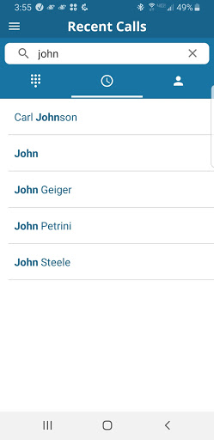

### 

### Voicemail

1. Click on the Voicemail menu item to see your visual voicemail.
   * The following information is available for each voicemail received:
     + Caller ID: the name & number of the person that left you a voicemail
     + Date & time
     + Voicemail transcription (if purchased)
2. The following actions are available for each voicemail:
   * Listen to voicemail
   * Callback
   * Send voicemail via email

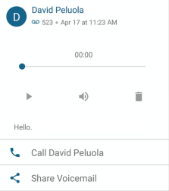

* + Delete by sliding voicemail entry to the left

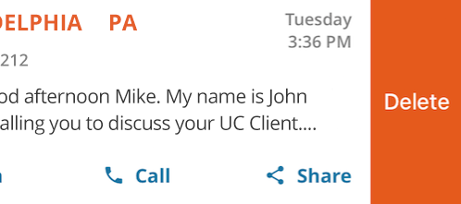

* + To delete multiple voicemails:
    - Click the avatar of one of the voicemails for deletion. You will notice a checkbox appears.
    - Select the other voicemail(s) you want to delete
    - Click Delete icon in the top right hand corner

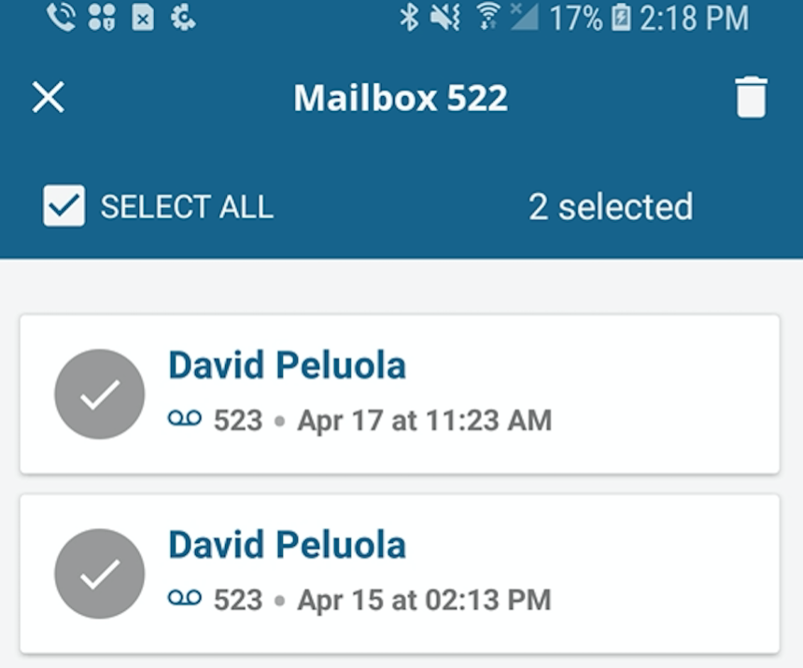

* + To delete all simply click Select All checkbox in the top left hand corner then click Delete icon

Changing Your Voicemail Greeting

1. To create/edit your voicemail Greeting, click Greeting in the top left hand corner

image5

1. Select the mailbox from the options. Select the greeting you wish to create/edit.

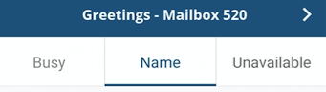

1. Tap the Record button to start/stop recording and click Save Changes at the bottom of the screen.  
     
   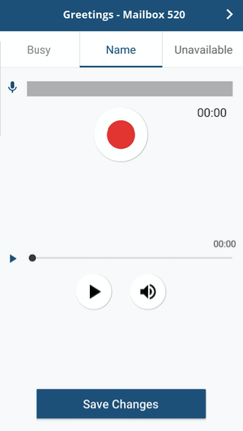

Conference Calls  
Provides a quick and easy way to moderate or attend a conference call .

1. A list of all conference call rooms will be provided.
2. Simply find the conference call you wish to moderate or attend and select the Attendee or Moderator button. The call will be instantly connected.
3. If there is a conference call bridge you frequently join simply click on the star to make it a favorite and it will appear at the top of the list.

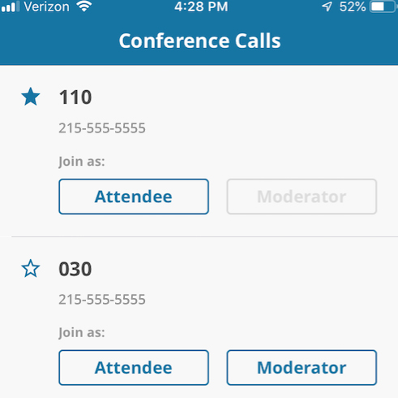

### Virtual Attendant Virtual Attendant serves as a virtual receptionist that greets customers while routing them to an available employee or to alternate devices of the employee they are trying to reach. CoreNexa Mobile provides the ability to perform this directly from the app.

* Select the Virtual Attendant
* Select Business Hours or After Hours
* Make changes to Schedule, Greeting, or Routing

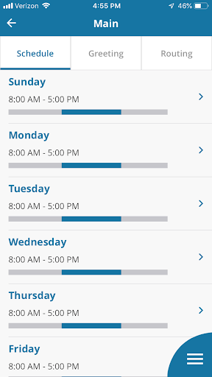 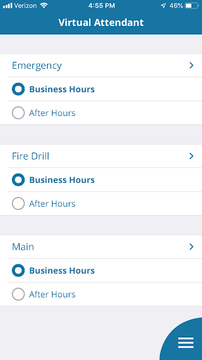

### 

### Settings Control Data Usage

If you want to control your data usage while using CoreNexa Mobile, you can select the desired data network with which to make and receive calls.

Inbound Calling  
The Inbound Calling option allows the ability to set inbound call control:

* Accept inbound calls via Wifi & cellular
* Accept inbound calls via Wifi
* Do not accept inbound calls

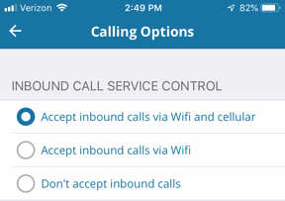

Do Not Disturb  
Allows the ability to stop notifications, alerts, and calls.

* To turn on: turn slider to the right



Note: When you enable "Do Not Disturb" or "Call Forward Always," an indicator appears in the lower right-hand corner of the main menu signaling these features are turned on.

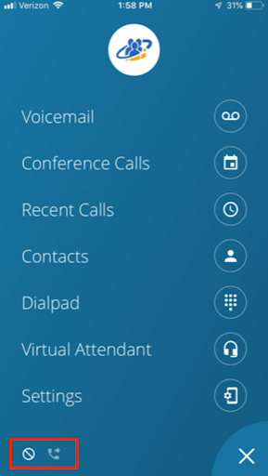

Call Forward Always  
Enables call forwarding to a preferred location.

1. To turn on - Click on the option
2. Select the Destination type
3. Click Save
4. When you go back to the main settings screen, the Call Forward Always icon will display as 'On'

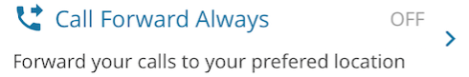

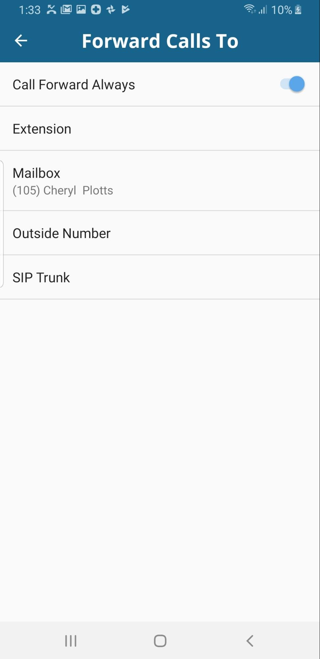

Recent Calls  
Display recent calls from preferred extension. If you have more than one extension, select the 'All Extensions' option.

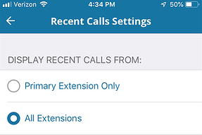

FAQs (Frequently Asked Questions)  
Find answers to many of your questions.

Leave Feedback  
Leave feedback about your app experience.