OBJECT REQUIRED
Kadota

- Launch the Event Viewer and open the System Events

- Look for a DCOM error and open it.

- Look for the CLSID in the Description portion of the event
Note: In the example below the ID is E054E9F4-FD19-4696-8A5B-11585DBDE2AF

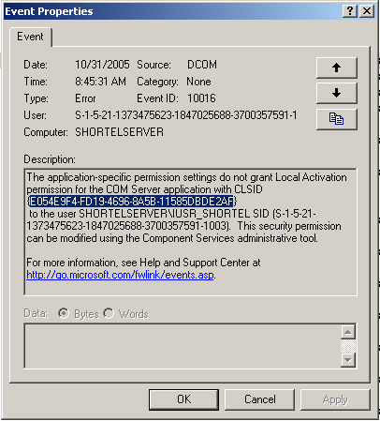

- Launch REGEDIT from Start – Run

- Search for the CSID. This will tell you the DCOM services that is restricting a ShoreTel login to the server
Note: In this case it was the KadotaUtil service

- Open Component Services from the Administrative Tools

- Expand the entries in the left window till you see DCOM Config

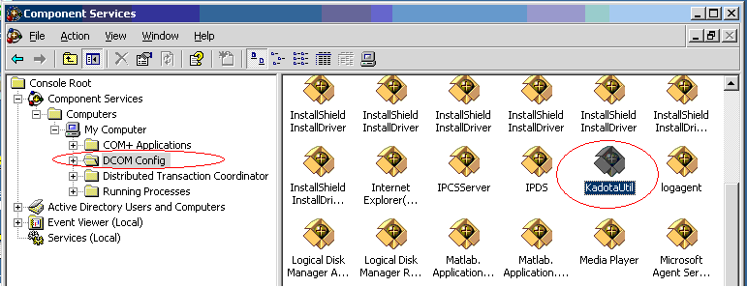

- Open the Properties of the “KadotaUtl”

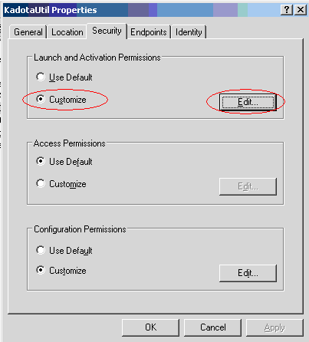

- In the “Launch and Activation Permissions” box select “Customize” then click Edit

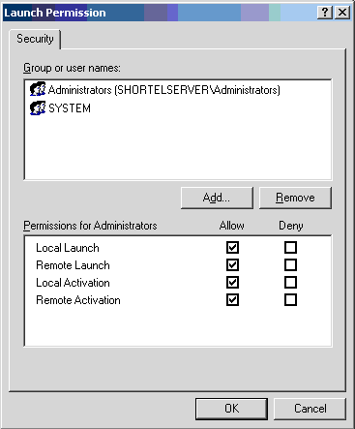

Note: The IUSR is missing

- Click Add

- Click Advanced

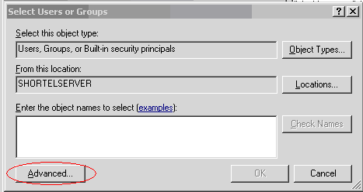

- Click “Find Now”

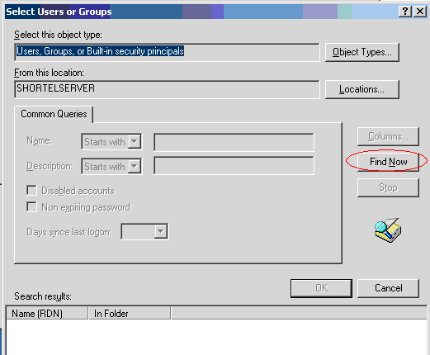

- Find and double click the IUSR

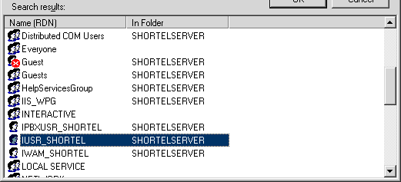

- Select all of the Allow check boxes and click OK

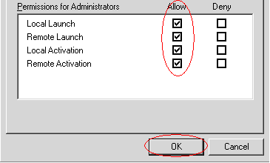

- Perform the same steps for the “Anonymous” and “IPBXUSR…”

