Title: | How to disable Data Execution Prevention (DEP) from Windows XP SP2 and Windows 2003 Server SP 1?
Category: | Troubleshooting/Event ID
ShoreTel Component: | Call Manager, Contact Center, Distributed Voice Mail server, ShoreWare Server
ShoreTel Feature: | Voice Mail, Voice Quality
Technical Note Number:
Publish for:
Release Date: | 2007-06-21
Author: | Erik Marzolf
Approved by:
Products Affected: | ShoreWare X_ / SBE X_:  X_ All _ 6.1 _ 6 _ 5R2 _ 5R1.2 _ 4 _ Other
ShoreGear:
_ All _ 120/24 _ 60/12 _ 40/8 _ T1 _ E1 _ 24 _ 12 _ Telework_ Softswitch _ Other
IP Phone:
_ All _ IP560 _ IP530 _ IP230 _ IP212K _ IP210 _ IP110
_ IP100 _ AP110 _ AP100 _ BB24 _ Other
Contact Center:
_ 4.6 _ 4.35 _ Other
Conference Bridge:
_ 5.6 _ 4.2 _ Other
 | Other:
The Data Execution Prevention (DEP) has been reported by customers that have affected ShoreTel systems. Below is a quick summary of problems been reported. After reviewing the problems list, you might be able to determine whether your problem is related.

Problem List:

Unable to install the following:

- ShoreTel Server software (HQ & DVM)

- ShoreTel PCM (Personal Call Manager)

- ShoreTel Contact Center software

- Contact Center Dongle drivers

Problems that occur:

Voicemail Related
When calling the one of the user on the ShoreTel system the voicemail picks up
However once you leave a message it does not allow you to save the message when
You press the keys to save the message for the user. It redirects the call to the backup
Auto attendant or dumps the call to silence.

If you determine the DEP might be the cause of your problem, please follow below STEPS to disable DEP from creating any problems on your system.

- ON YOUR DESKTOP RIGHT CLICK ON MY COMPUTER AND CLICK ON PROPERTIES

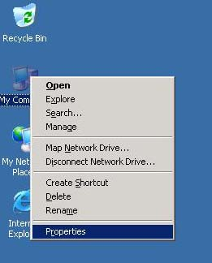

- THEN CLICK ON THE ADVANCED TAB

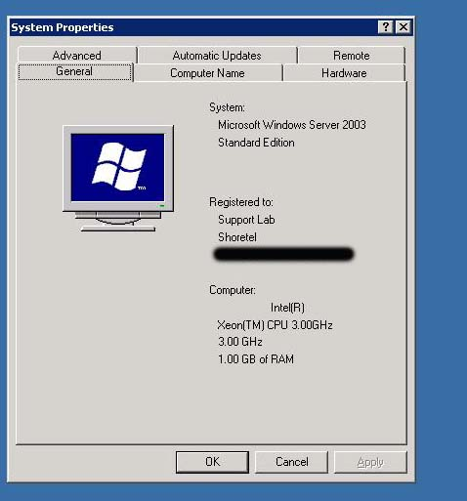

- CLICK ON THE SETTING BUTTON UNDER THE PERFORMANCE FRAME

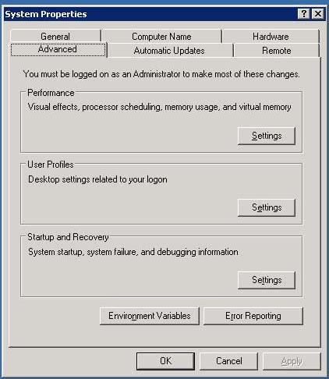

- IF YOU SEE THE DEP SETTING ON THE BOTTOM RADIAL CHOICE THIS IS INCORRECT AND IT WILL CAUSES ALL THE ABOVE PROBLEMS

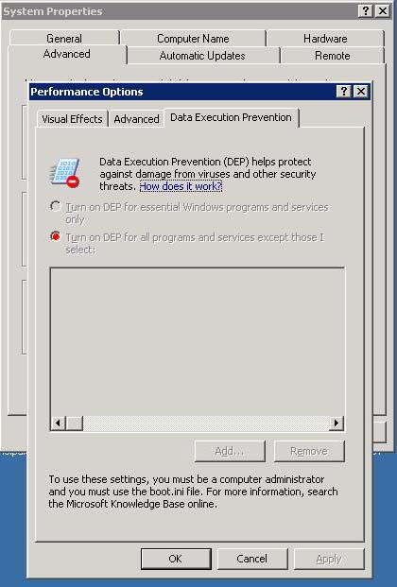

- YOU WILL NEED TO CHOOSE THE UPPER RADIAL BOTTON, THIS WILL PROMPTTHE USER TO REBOOT THE SERVER OR WORK STATION THIS IS NEEDED TO ORDERFOR THE NEW SETTING TO TAKE EFFECT

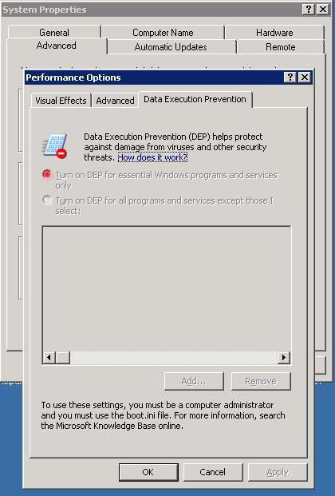

- AFTER THE SERVER OR WORKSTATION HAS REBOOTED PLEASE DOUBLE CHECK THE SETTING TO MAKE SURE IT’S ON THE UPPER RADIAL BOTTON BEFORE PROCEEDING WITH THE INSTALLATION

BELOW YOU WILL FIND BRIEF INFORMATION ABOUT WHAT DEP DOES AND HOW IT AFFECTS THE SYSTEM. PLEASE REFER to MICROSOFT FOR DETAIL INFORMATION!

OptIn | This setting is the default configuration. On systems with processors that can implement hardware-enforced DEP, DEP is enabled by default for limited system binaries and programs that "opt-in." With this option, only Windows system binaries are covered by DEP by default.
OptOut | DEP is enabled by default for all processes. You can manually create a list of specific programs that do not have DEP applied by using the System dialog box in Control Panel. Information technology (IT) professionals can use the Application Compatibility Toolkit to "opt-out" one or more programs from DEP protection. System compatibility fixes, or shims, for DEP do take effect.
AlwaysOn | This setting provides full DEP coverage for the whole system. All processes always run with DEP applied. The exceptions list to exempt specific programs from DEP protection is not available. System compatibility fixes for DEP do not take effect. Programs that have been opted-out by using the Application Compatibility Toolkit run with DEP applied.
AlwaysOff | This setting does not provide any DEP coverage for any part of the system, regardless of hardware DEP support. The processor does not run in PAE mode unless the /PAE option is present in the Boot.ini file.

The Boot.ini file settings are as follows:
/noexecute=policy_level
Note policy_level is defined as AlwaysOn, AlwaysOff, OptIn, or OptOut.
Existing /noexecute settings in the Boot.ini file are not changed when Windows XP SP2 is installed. These settings are also not changed if a Windows operating system image is moved across computers with or without hardware-enforced DEP support.
During installation of Windows XP SP2 and Windows Server 2003 SP1 or later versions, the OptIn policy level is enabled by default unless a different policy level is specified in an unattended installation. If the /noexecute=policy_level setting is not present in the Boot.ini file for a version of Windows that supports DEP, the behavior is the same as if the /noexecute=OptIn setting was included.
If you are logged on as an administrator, you can manually configure DEP to switch between the OptIn and OptOut policies by using the Data Execution Prevention tab in System Properties. The following procedure describes how to manually configure DEP on the computer:

1. | Click Start, click Run, type sysdm.cpl, and then click OK.
2. | On the Advanced tab, under Performance, click Settings.
3. | On the Data Execution Prevention tab, use one of the following procedures:
  • | Click Turn on DEP for essential Windows programs and services only to select the OptIn policy.
  • | Click Turn on DEP for all programs and services except those I select to select the OptOut policy, and then click Add to add the programs that you do not want to use the DEP feature.
4. | Click OK two times.

IT professionals can control system-wide DEP configuration by using a variety of methods. The Boot.ini file can be modified directly with scripting mechanisms or with the Bootcfg.exe tool that is included in Windows XP SP2.
To configure DEP to switch to the AlwaysOn policy by using the Boot.ini file, follow these steps:
1. | Click Start, right-click My Computer, and then click Properties.
2. | Click the Advanced tab, and then click Settings under the Startup and Recovery field.
3. | In the System startup field, click Edit. The Boot.ini file opens in Notepad.
4. | In Notepad, click Find on the Edit menu.
5. | In the Find what box, type /noexecute, and then click Find Next.
6. | In the Find dialog box, click Cancel.
7. | Replace policy_level with AlwaysOn.  WARNING Make sure that you enter the text accurately. The Boot.ini file switch should now read:  /noexecute=AlwaysOn
8. | In Notepad, click Save on the File menu.
9. | Click OK two times.
10. | Restart the computer.

