YOU MUST DO THE TELNET FROM THE HQ SERVER
For Server 2008
By default telnet is not enabled
To enable telnet follow the steps below

- Open Server Manager by clicking Start > Server Manager, or by using the My Computer context menu.
- From the left panel in Server Manager, click on Features.
- Click on Add Features.
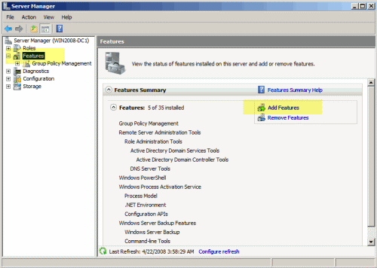
- From the available list of features, scroll down and select Telnet Client, then click Next.
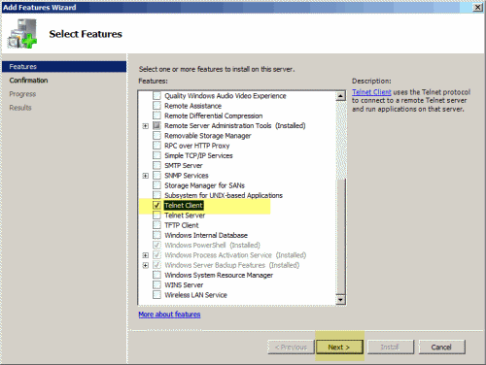
- On the Confirmation page, click on Install.
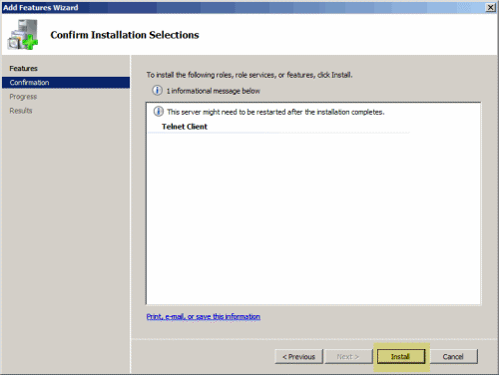
- Installation of the selected feature will be initialized and started. Once installation is completed, click on Close.
- I recommend a full reboot of items needing telnet access
To Telnet in 2008…Follow the information below
cd\
cd *(x86)\sh*\*er

ipbxctl -telneton ipaddress
password: ShoreTel (for older switches skip this step)

telnet ipaddress

log: anonymous
pass:ShoreTel

command example:
lsp_ping "ip address"

bootChange

FOR PHONES

phonectl -pw 1234 -telneton 192.168.1.5

you need to authenticate with a password. default is 1234

BurnFlash
CD C:\prog*\Shore*\*ver
burnflash –s 192.168.1.xx
This will re-flash the switch with new firmware

