**KB00000375**

**How to SSH to a ShoreTel ST Switch**

In order to setup a SSH session to a ShoreTel ST switch, use the following steps:

1.       Install puttygen on the HQ server

2.     Click on puttygen and click on Load and existing private key file

3.     Navigate to Shorelinedata\keystore\ssh\hq_rsa and click enter  
***NOTE:*** *make sure to change to All Files or the key will not show up in the folder*  
  
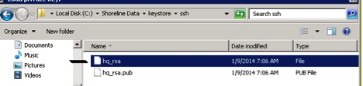  
  
***NOTE  
  
User-added image***

4.     Once the key is loaded click on Save private key, you will receive the popup click yes to save without a passphrase  
  
User-added image  
  
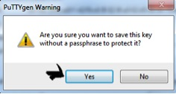

5.     Name the key and save this---I used ST1 as the name of the key

6.     Use putty in SSH mode and enter the IP of the switch  
  
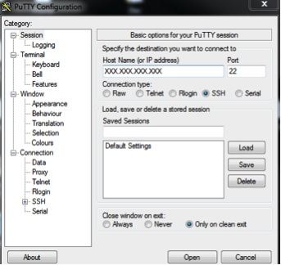

7.     In the left column click on the SSH Tab  
  
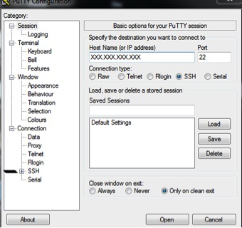

8.     This will show drop down options, click on the AUTH, then click on the Browse button  
  
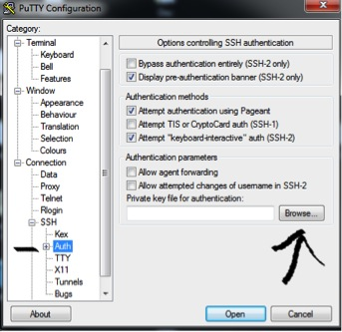

9.     When you click on the browse button this should take to the correct folder and select the ST1 key, click on the key, it will show in the line then click open, the correct folder is C:ShorelineData\keystore\ssh, the key will show up as in example **ST1** as a putty private key.

10.   Right click on the key and then click on the Open. This will start the SSH session to the switch.

11. Use “admin” as the login and “ShoreTel” as the password