How to do a Closing Early Custom menu change
-go to schedules on left column
-select the Closing Early item and edit date and time (this example is 10/07/2016)

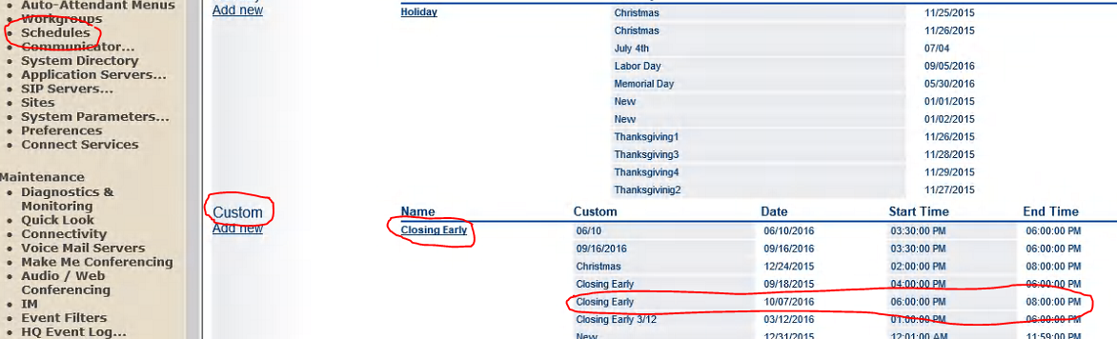

Adding Holidays or editing existing hours of operation are done in the same way.

Editing the existing Message in Auto Attendant
-Go to Auto-Attendant on left Column
-Select the Auto-Attendant you want to edit (this example Main AA)
-Select the greeting you want to alter (in this example it is the Custom tab, see the arrow is pointing down)
-Click record button and when finished recording click OK and go to top of screen and hit SAVE

