How to Configure DSCP on a Windows 2012 Server

Answer
Details
Packet captures from ShoreTel servers are indicating no DSCP tagging is placed causing packets to not be prioritized over the network as desired.
For steps on configuring Server 2008 please see article 000001964. Please note there are some additional options contained in 000001964 for more granular QOS rules which may be of interest.
Please Reference ST AN10326 – Data Network Best Practices for Shoretel VoIP for more detail surrounding our networking best practices: http://support.shoretel.com/kb/view.php?id=kA4C00000008c5EKAQ
Answer
Please see the following instructions below to enable QOS on the Windows Server. For additional details on this configuration please contact Microsoft Support.
If the Server is on the Domain:
- Click the windows icon and search box type “edit group policy” and hit the search item to open up the Local Group Policy Editor.Under Computer configuration->Windows Setting select policy-based QoS. Proceed to steps following the first image.
For Servers Not on the Domain:
- Open the Run Prompt
- Type mmc and then enter
- Click file then Add/Remove Snap-in
- Select Group Policy Object Editor
- Select the server you are working on
- Under Computer configuration ->Windows Setting select policy-based QoS
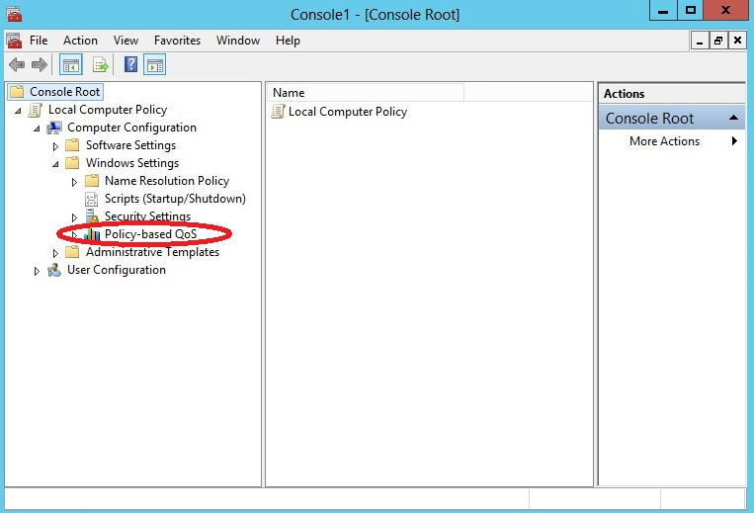
- Right click and select Advanced QOS Settings
- Select the DSCP Marking Override Tab
- Check the check boxes to allow application to control DSCP marking request as below and select OK
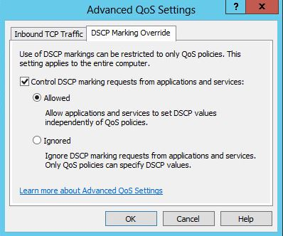
- Again right click policy-based QoS to create new policy. Enter the name of the policy. In the “Specify DSCP value” enter the same DiffServ/ToS value specified in the director. Note that this value should be in the range of 0-63. Click next. Note: value defined in the screenshot is an example not the expected configuration.
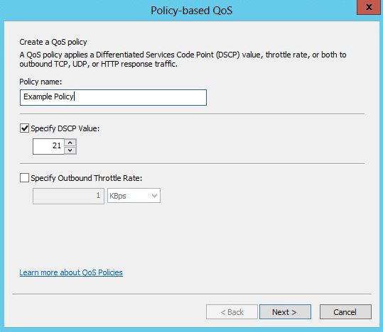
- In the next dialog leave all the default value and click next.
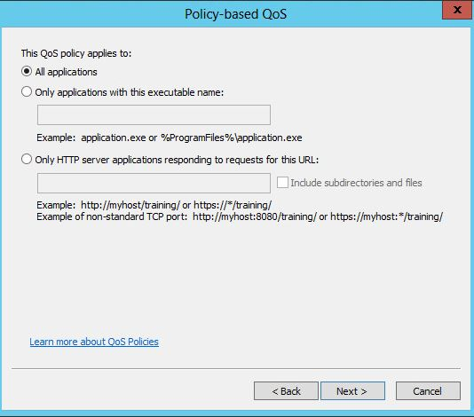
- From the drop down menu, select TCP and UDP and leave the default value for all other parameters. Click Finish. This will enable DSCP in the box.
