How to change the MTU value in Mitel Connect

OBJECTIVE:
- Step 1 Determine site MTU size
- Step 2 Check switch MTU
- Step 3 Change the global MTU value
- Step 4 Verify MTU changed

Step1: Determining Site MTU
To quickly assess a WAN path’s PMTU, execute a series of ping tests using the following command at a Window’s CDM prompt from the remote end of the WAN tunnel connection;
ping <HQ server IP> -f -l XXXX (e.g. ping <HQ server IP> -f -l 1400), where XXXX is the packet size.

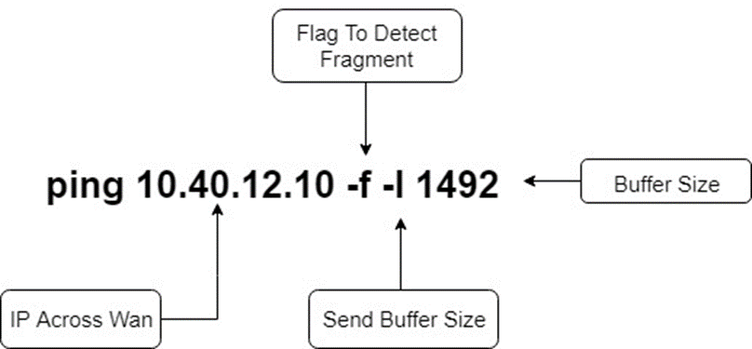
Begin increasing or decreasing the packet size from this number in small increments until you find the largest allowable size that does not fragment and successfully pings.

EXAMPLES:
1500 Fail
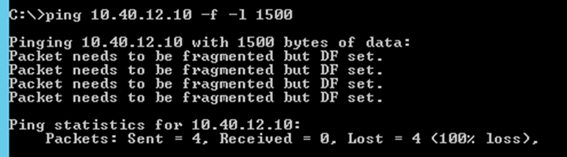
1400 Fail
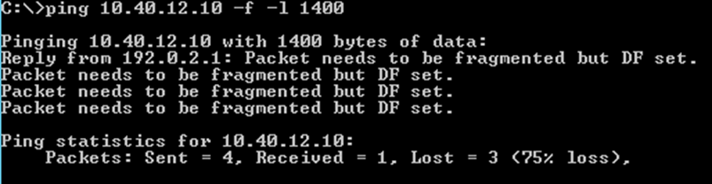
1393 Fail
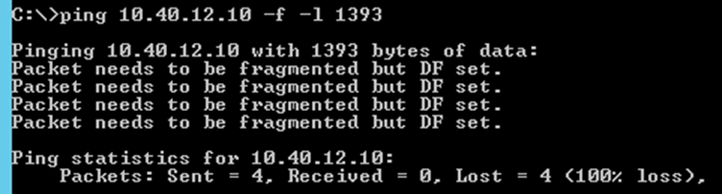
1392 Pass (This is our MAX MTU)
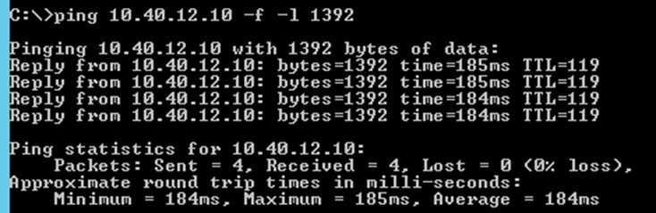

Step 2: Checking our switch MTU
Now that we know our site MTU can be no more than 1392 let’s check one of our switches for the MTU value.

From the HQ server:
Open CMD Then Type:
Ipbxctl –telneton <switch IP>
telnet <switch IP>
Login: anonymous
Password: ShoreTel
Then type gotoshell
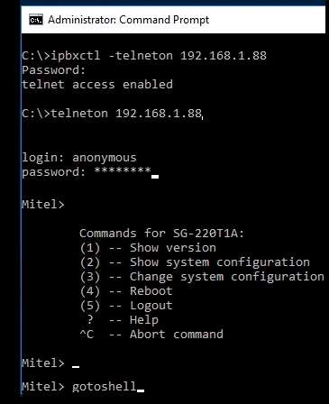

Once you see the ->
type ifShow ( S must be capitalized)
Now look for the Maximum Transfer Unit size is XXXX
This number is the max MTU for the switch
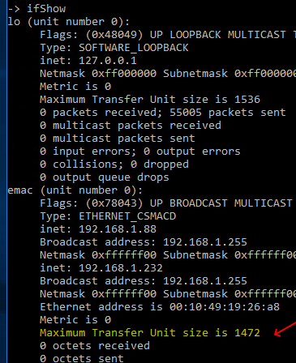
If you leave this session open during step 3 you will actually see a notice stating the MTU has been changed.

Step 3: Changing the max MTU
Directly Login into the server and then open the registry aka regedit.exe
From within the registry editor navigate to the following key and edit it:
HKEY_LOCAL_MACHINE\SOFTWARE\Wow6432Node\Shoreline Teleworks\Telephony Management Server\Settings Key Name= SwitchDebug

Add this parameter and the appropriate value to the end of the string ether_mtu_size max mtu here. Use your max value that you found from our previous ping tests.
Default Value= debug_options onhook_dialing_for_IP110 1.
New Value Example= debug_options onhook_dialing_for_IP110 1 ether_mtu_size 1472.

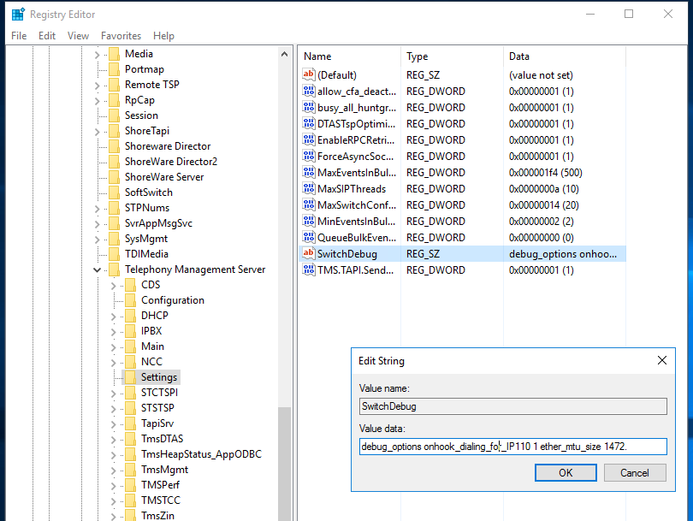

Saving this key instantly changes the MTU value globally.

Step 4: Verify the MTU Value
Repeat step 2 to see if the value changed. Also note if you never closed the ipbxctl session from step 3 you would see this notice stating the change.
