How To Telnet a ShoreGear Switch To Edit Existing Network Settings
This Applies to SG120/24, SG60/12, SG24, SG30, SG50, SG90, 220T1, 220T1A, T1 and all non Voice Mail Shore Gear Switches
(Excludes V switches and ST switches)

To telnet into a SG switch requires direct access to your local controlling server and the use of windows command line. For the example below I will be using 192.168.1.89 as my ip address for my switch. Please replace the value with you own valid local ip address.

Open CMD and navigate to the directory that holds the ipbxctl connector for your sg switch.

64 BIT WINDOWS Directions (each line represent hitting the enter key)
cd\
cd pro*/sho*/*er
ipbxctl –telneton 192.168.1.89
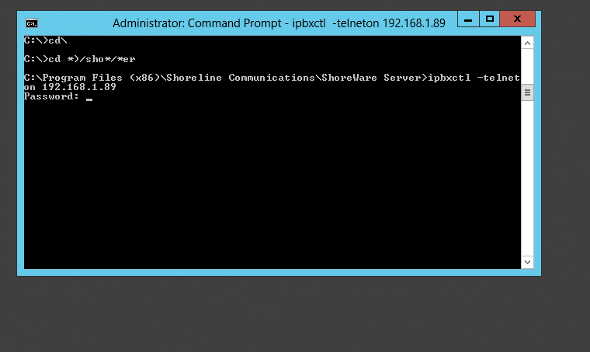
Enter the Password: ShoreTel (the password is case sensitive)
You should now see Telnet enabled
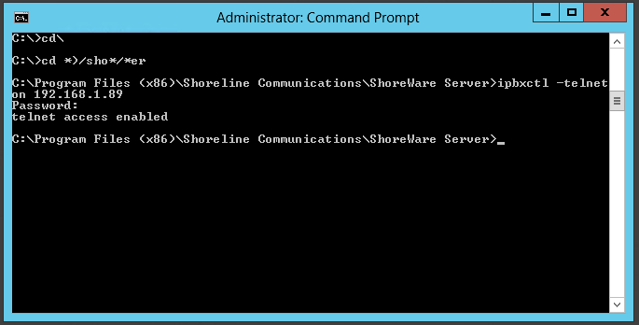

From here you should be able to enter Vxwork by typing:
telnet 192.168.1.89

You will now be prompted for a user and password
VxWorks login: anonymous
Password: ShoreTel (the passwords are case sensitive)

You should visibly see a vxworks prompt (some modern switches will log directly into the GUI)
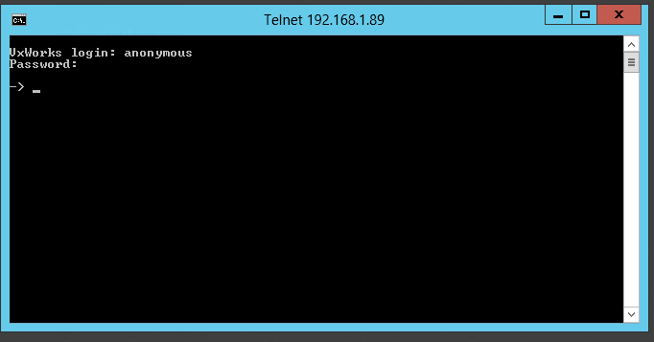
To enter into the GUI from the prompt type cliStart and hit enter.
You should now see the ShoreTel interface as seen below.
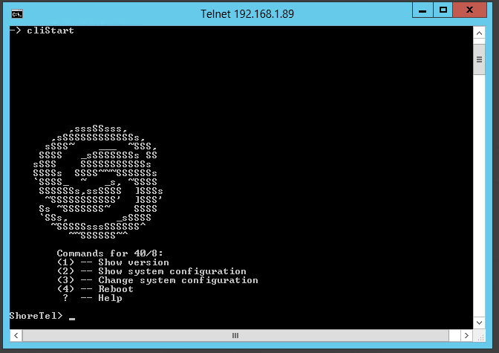

Hopefully this is helpful to someone

Thank You
Lance Paddock

