**ShoreTel Windows DCOM error "1385"**

**Symptom:** Director won’t open and 1 or more shoretel services will not start.

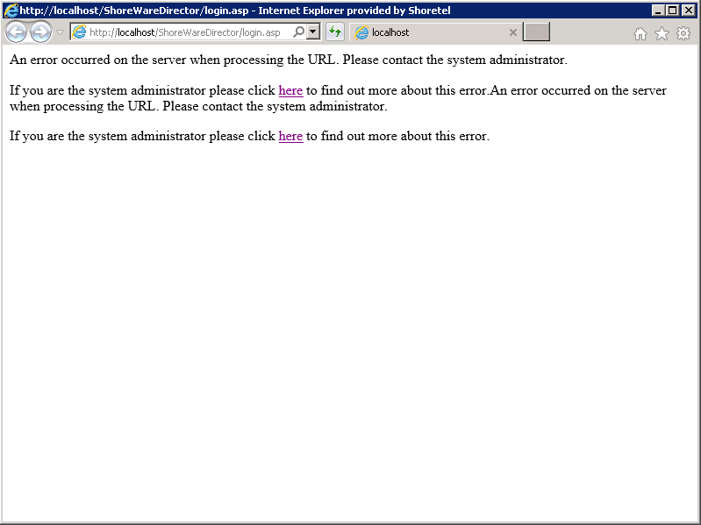

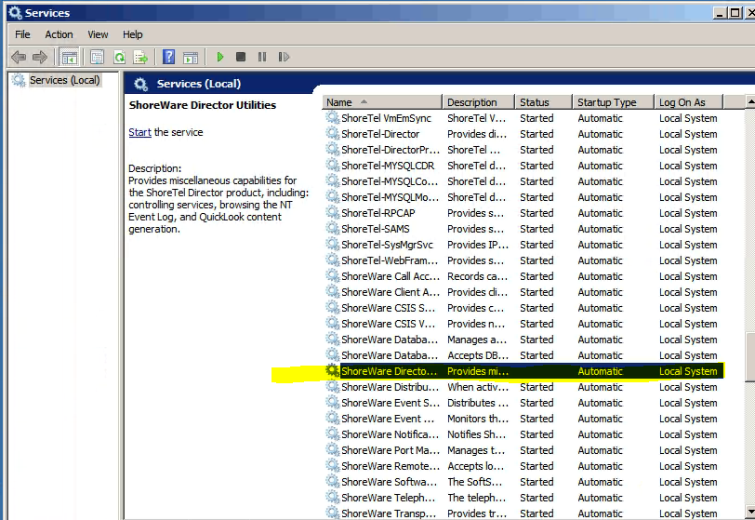

**Solution:**

* Navigate to: Administrator Tools>Component Services>Computers>My Computer>COM+ Applications
* Right Click: “**ShoreWare”** to select properties.
* From within properties select the **“Identity”** tab
* From within the identity tab change the **Account** type to **“System Account”** with Interactive user then hit save.
* Right click the **“Shoreware”** component service to restart the service

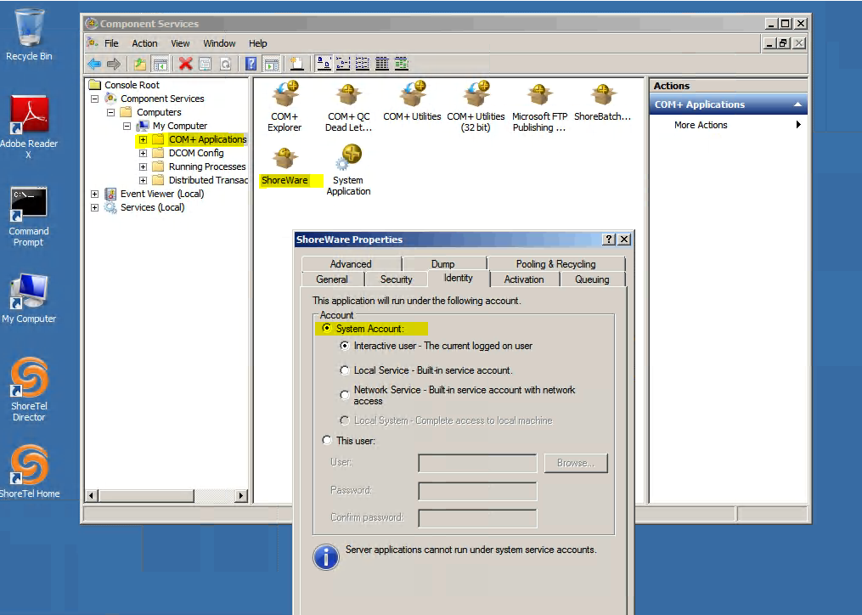

You should now see the service start.