ShoreTel v-switches require time to be reachable or the voice mail services will not work, start or shutdown.

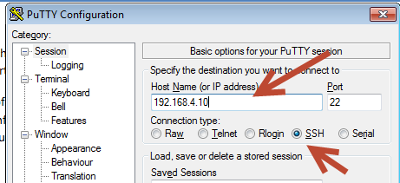
After logging in using the admin user name and password you were presented with the following screen.

Setting NTP through Configuration Screen
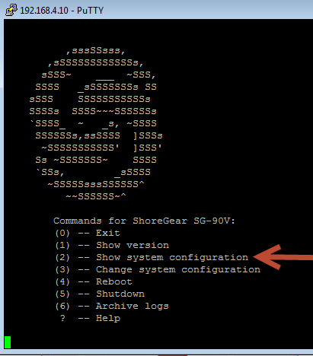
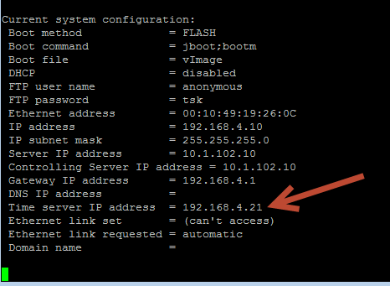
The way to check to see if the voice mail services are actually running is to log back into the vswitch and run the svccli command and then getstatus command.
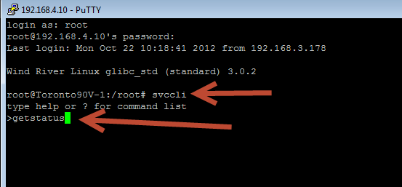
Once you hit enter you will see…
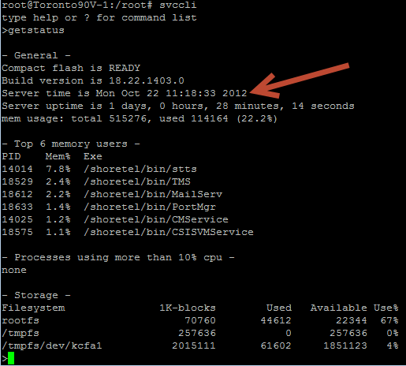

If you see <<<Time Server has not been set>>> message the time server (NTP) setting is either incorrect or not reachable.
The next test is to ctrl-z back to the main root login and run the date command to see what time the actual v-switch is currently running.

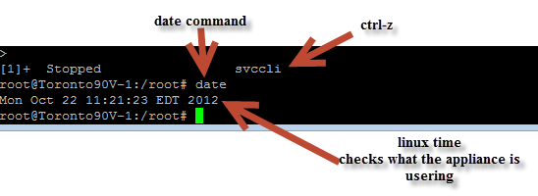

Manually setting time in V-switch
What you can do if you need to get the voice services back up and running is to run a date –set command that will get the switch the correct time and the voice mail services can start while you figure out why the NTP setting is not working.
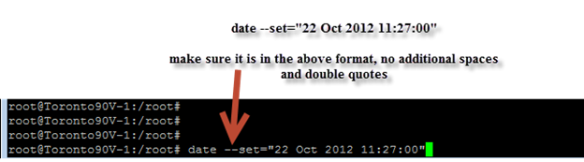
Then run the date
command again to see if the date and time were updated. If so you can try and restart the voice mail services or wait for them to restart.

