ShoreTel MOH and Paging
2 Wire Stereo Adapter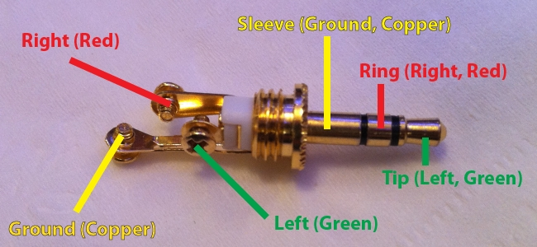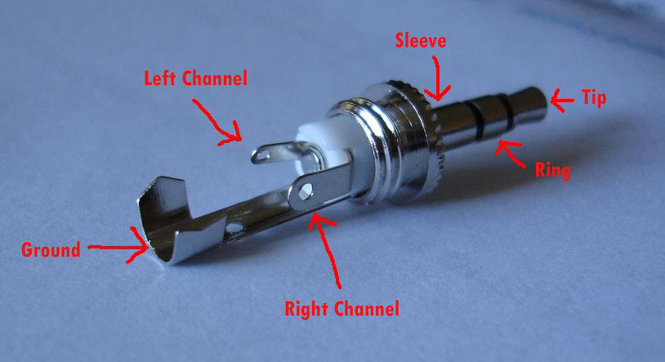

ShoreTel uses the right channel of a stereo tip

