**How to SSH into a 4 Series phone**

# Objective:

To SSH into a 4 series phone requires a terminal emulator like Putty, a private key for your SSH session, and the local ip of the phone you desire to SSH into

# Steps and Procedures used To SSH

1. Download and Install **PuttyGen**
2. Open PuTTyGen and select **Load** an existing private key file. The key we need is named **“hq_rs**a”

Navigate to **Shorelinedata\keystore\ssh\hq_rs**a and click enter  
***NOTE:*** *make sure to change the file type to* ***All Files (*.*)*** *or the key will not show up in the folder*

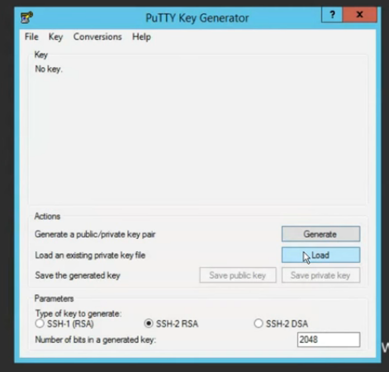***User-added image***

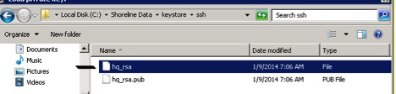

1. Click open once the key is selected and then click ok to the foreign key notice

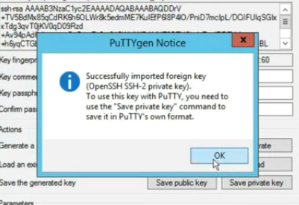

1. After the key is loaded click on the **Save private key** and **Confirm the prompt** to save this key without a passphrase.   
     
   User-added image  
     
   
2. Once you have saved the key be sure to take note of the name and location of the .ppk as we will be using this key in PuTTy to secure or SSH
3. Close PuTTYgen
4. Open PuTTy and then enter the **IP** of your device in the **Host Name (or IP address)** field

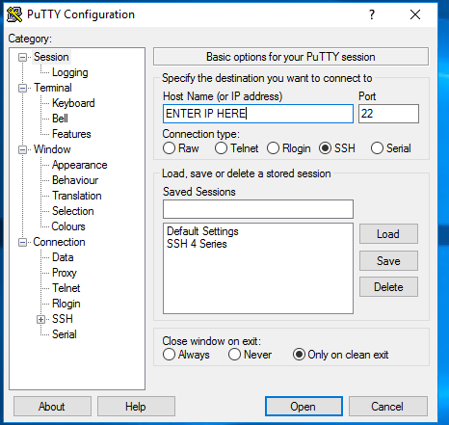

1. Then In the left column select the **SSH** Tab and open it

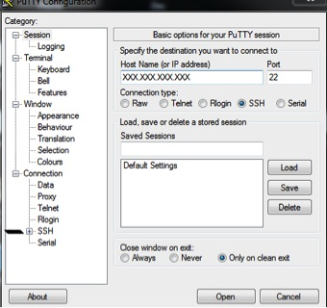

1. This will open a drop down menu and we want to click on the **AUTH**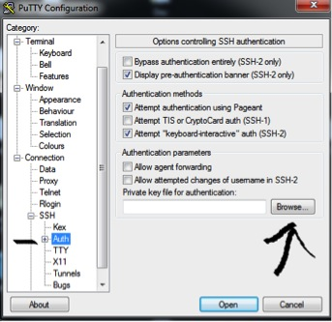
2. Then click on the browse button and locate your newly created PuTYgen private key. Upon loading this key you are now staged to SSH into your device
3. Next we need to navigate to the **Session** tab followed by **open button** located at the bottom right
4. You should now see a Login screen

Use **“admin”** as the login and your session will begin to your phone

